

The University of Hong Kong

Faculty of Engineering

Department of Computer Science

COMP7705

Revised Project Report

An AI Approach for Optimization of Systematic Signal Detection in Cryptocurrencies Trading System with Big Data

Submitted in partial fulfillment of the requirements for the admission to the degree of Master of Science in Computer Science

By

Wong Ka Kit 3035753515

Wong Ngai Sum 3035380875

Lin Ho Ching Janus 3035754181

Supervisor: Dr. Jingrui Zhang

Date of submission: 15/08/2022

# Abstract

Ethereum's market cap is USD 363.11 million as of 2022. It is one of the largest capital and liquidity cryptocurrency markets. It has also become an increasingly popular alternative and attractive asset for investment recently. In this project, we aim to create an advanced trading strategy by applying big data with machine learning models. We used Ethereum Future, Bitcoin, VOO and QQQ candlestick data, Twitter social media data, fear and greed index data, and technical indicators to develop 6 machine learning models, including CNN, KNN, MLP, LSTM, RF, and XGB. Apart from these, we have also backtested traditional rule-based strategies like SMA crossover and Bolling band and attempted to combine different models. In general, we found that some of the machine learning models, and traditional models can generate positive results. However, machine learning tends to have a higher trade frequency than traditional rule-based models. Thus, when the trading fee increase, the return from machine learning models will decrease or even losing money.

# Declaration

The following work was completed by us under the guidance of the supervisor. The work we submitted is original. About the reference code and materials from the open internet, we cited them in the references part. We understand the policies and regulations of the university on the honesty of academic work, as well as the disciplinary guidelines and procedures.

# Acknowledgements

We would like to express our gratitude to our supervisor Dr. Zhang, who provided guidance patiently throughout this project. Our sincere thanks also go to people who generously shared their knowledge online such as offering free courses on Coursera and answering questions on Stack Overflow, and people who contributed to open-source projects like Keras. Without their generosity, this project would not have been possible. We would also like to thank all the people who contributed or supported in some ways to the completion of this project.

Personal words from Wong Ngai Sum:

I would like to thank God, for letting me through all the obstacles during the study of this degree. I will keep on believing in you in my future. I would also like to thank musicians who created great music that accompanied me such as Ludwig van Beethoven. I also take this opportunity to thank my piano teacher, Irene. She cheered me up on numerous hard days and her bright smile melted my heart. Thanks to her, I am ready to pursue postgraduate studies in music and start my new chapter of life.

# Table of Contents

Abstract 1

Declaration 2

Acknowledgements 3

Table of Contents 4

List of Tables 7

List of Figures 8

1. Introduction 9

1.2 Motivation 9

1.3 Project aims and objectives 10

1.4 Organization of the report 10

2. Literature Review 12

2.1 Machine learning techniques 12

2.1.1 Mining netizen's opinion on cryptocurrency: sentiment analysis of Twitter data [2] 12

2.1.2 Price movement prediction of cryptocurrencies using sentiment analysis and machine learning [5] 13

2.1.3 Trading on Twitter: using social media sentiment to predict stock returns [6] 14

2.1.4 On technical trading and social media indicators in cryptocurrencies' price classification through deep learning [1] 15

2.1.5 Survey on the application of deep learning in algorithmic trading [7] 17

2.2 Technical analysis techniques 19

2.2.1 Technical trading rules in the cryptocurrency market [9] 19

2.2.2 The profitability of Bollinger Bands trading bitcoin futures [10] 20

3. Methodology 21

3.1 Product to trade: Ethereum’s USDM perpetual futures 21

3.2 Tool for backtesting: backtest.py 22

3.3 Data collection 23

3.3.1 ETH futures and BTC candlestick data 23

3.3.2 Fear and greed index 24

3.3.3 ETF price data: VOO, QQQ 25

3.3.4 Twitter tweets data 25

3.4 Data preprocessing 26

3.4.1 Fear and greed index 26

3.4.2 ETF price data 26

3.4.3 Twitter tweets 26

3.5 Input features, common preprocess pipeline, and class labeling 27

3.5.1 Input features 27

3.5.2 Preprocess pipeline of machine learning models 29

3.5.3 Class labeling 31

3.6 Result validation - Walk Forward Testing 31

3.7 Models for trading signal generation 32

3.7.1 Convolutional Neural Network (CNN) 32

3.7.2 Multilayer Perceptron (MLP) 36

3.7.3 Long Short-Term Memory (LSTM) 36

3.7.4 K-Nearest Neighbor (KNN) 39

3.7.5 Random Forest (RF) 39

3.7.6 XGBoost (XGB) 40

3.7.7 Simple Moving Average (SMA) model 41

3.7.8 Simple Moving Average (SMA) plus Bollinger Band (BB) model 43

3.7.9 Combined model 45

3.8 Machine learning models for sentiment analysis 45

3.8.1 Twitter-roBERTa-base-latest for sentiment analysis 46

3.8.2 roBERTa-base trained with emotion dataset 47

3.8.3 CryptoBERT 48

3.9 Result evaluation 48

4. Results 50

4.1 Performance of buy and hold 50

4.2 Performance of MLP 51

4.2 Performance of KNN 53

4.3 Performance of LSTM 55

4.4 Performance of RF 57

4.5 Performance of XGB 59

4.6 Performance of CNN 61

4.7 Performance of SMA 63

4.8 Performance of SMA plus BB 66

4.9 Performance of combined model (all ML models) 69

4.10 Performance of combined model (well-performed ML models) 71

4.11 Summary table of all model performance 73

5. Discussion 74

5.1 Usefulness of non-ETH pricing data 74

5.2 Volatile return because of a volatile market? 75

5.3 Buy and hold strategy 76

5.4 Is combined model necessarily better? What else to do to make it better? 77

5.5 Trading fee consideration 78

5.6 ML vs Traditional: return, risk, trade frequency 78

5.7 Inefficient market 79

5.8 What is the “tread”? How to capture it successfully? 79

5.9 History doesn't really repeat itself? 80

6. Challenges 82

6.1 Too much noise in Twitter data 82

6.2 Determine the architecture of neural networks like CNN 82

6.3 Not enough data because Ethereum futures contract is new 82

6.4 Difficult to evaluate the fair value of cryptocurrency 83

7. Future work 84

7.1 More complex models 84

7.2 Better and more variety of social media data 84

7.3 Grid search for hyperparameters tuning 84

7.4 TP/SL/Dynamic Position Size trading strategies 85

7.5 More alphas & new technical indicators 85

7.6 More comprehensive traditional rule-based models 85

7.7 Genetic Algorithms to pick models or assign weights 86

7.8 Combine machine learning models with traditional technical strategies 86

7.9 Further extending the sample type, size, and testing period 86

7.10 Portfolio optimization 87

8. Conclusions 88

Bibliography 90

Appendices 93

Declaration of the contribution of each individual member of the group 96

# List of Tables

Table 1: Input features (not including the social media indicators) for training the machine learning models 29

Table 2: Parameters of our CNN model 35

Table 3: Parameters of our MLP model 36

Table 4: Parameters of our LSTM model 38

Table 5: Parameters of our KNN model 39

Table 6: Parameters of our RF model 40

Table 7: Parameters of our XGB model 40

Table 8: Multiple settings of backtesting that were tested 49

Table 9: Confusion matrix of Buy and Hold 50

Table 10: P/L statistics of Buy and Hold with different trading fees 50

Table 11: Confusion matrix of MLP model 51

Table 12: P/L statistics of MLP model with different trading fees 52

Table 13: Confusion matrix of KNN model 54

Table 14: P/L statistics of KNN model with different trading fees 54

Table 15: Confusion matrix of LSTM model 55

Table 16: P/L statistics of LSTM model with different trading fees 56

Table 17: Confusion matrix of RF model 57

Table 18: P/L statistics of RF model with different trading fees 58

Table 19: Confusion matrix of XGB model 59

Table 20: P/L statistics of XGB model with different trading fees 60

Table 21: Confusion matrix of CNN model 62

Table 22: P/L statistics of CNN model with different trading fees 62

Table 23: P/L statistics of SMA model with different trading fees 65

Table 24: P/L statistic of SMA with BB model with different trading fees 67

Table 25: Confusion matrix of combined model (All ML models) 69

Table 26: P/L statistic of combined model (All ML models) with different trading fees 69

Table 27: Confusion matrix of combined model (Well-performed ML models) 71

Table 28: P/L statistic of combined model (Well-performed ML models) with different trading fees 71

# List of Figures

Figure 1: Convolutional layer, adapted from [23] 34

Figure 2: The gates of an LSTM cell, adapted from [25] 37

Figure 3: Equity curve of Buy and Hold 51

Figure 4: Equity curve of MLP 53

Figure 5: Equity curve of KNN 55

Figure 6: Equity curve of LSTM 57

Figure 7: Equity curve of RF 59

Figure 8: Equity curve of XGB 61

Figure 9: Equity curve of CNN 63

Figure 10: Equity curve of SMA 64

Figure 11: Equity curve of SMA with Bolling band 67

Figure 12: Equity curve of combined model (All ML models) 70

Figure 13: Equity curve of combined model (Well-performed ML models) 72

# 1. Introduction

In this project, we have implemented an advanced trading strategy for Ethereum Futures by combining multiple data models using machine learning models such as Convolutional Neural Network, Multilayer Perceptron, Long Short-Term Memory, as well as other rule-based strategy models to generate trading signals.

### 1.2 Motivation

Machine learning is now one of the most popular topics in many fields, such as financial fraud detection, genome annotation, and text mining. As the amount of available social media data is growing, many researchers have been trying to build profitable trading strategies in financial markets, by utilizing sentiment data from news websites, and social media websites like Twitter and Reddit [1]. Other than machine learning techniques, proficient traders use fundamental analysis and technical analysis techniques to forecast price movement for different periods of time. This project focuses on prediction of short-term movements, thus fundamental analysis may not be useful. We intend to use both machine learning and technical analysis techniques to build trading strategies, compare their performance and try to combine outputs from these models for better prediction.

### 1.3 Project aims and objectives

This project aims to create an advanced trading strategy by combining multiple techniques using different machine learning techniques, including deep learning and natural language processing (NLP) to analyze the market sentiment through social media data from Twitter, and the market patterns through historical pricing data of Ethereum, as well as pricing data of potentially correlated assets including Bitcoin, Vanguard 500 Index Fund ETF (VOO), and Invesco QQQ Trust ETF (QQQ). For machine learning models, they have three possible outputs: 1 for buy signals, 0 for hold signals, and -1 for sell signals. For the traditional financial models, they would try to identify the trend and buy when the price is expected to going up and sell when the price is expected to going down. The final trading decision is derived from these models using majority voting, to generate maximum profit from the cryptocurrency market.

### 1.4 Organization of the report

The report is structured as follows:

1. Reviews on studies of machine learning and technical analysis techniques in trading are presented. How these studies provided insights and motivated our research will be included.
2. The methodology will be presented, starting from what product to trade, what tool to use for backtesting, what data to use and how to fetch and preprocess them, input features to the machine learning models and the preprocess pipeline before feeding to the models. After that, machine learning models that we used to generate signals and extract sentiment features, as well as the evaluation method of the results will be included.
3. Results and comparison between models based on different metrics
4. Discussion: analyze the usefulness of some features, the performance of the models, etc.
5. Challenges and next work

# 2. Literature Review

There is lots of research on using machine learning and technical analysis to do trading. We picked some of the papers and tried to learn from and improve their techniques.

### 2.1 Machine learning techniques

#### 2.1.1 Mining netizen's opinion on cryptocurrency: sentiment analysis of Twitter data [2]

In this study, Hassan et al. used RStudio to perform automated web-scraping to sample 15,000 tweets from Twitter. They found that most tweets have a positive sentiment. This study also found that the Twitter data related to cryptocurrency can be classified as 8 diverse types of emotions, namely anger, anticipation, disgust, fear, joy, sadness, surprise, and trust. This research also referenced previous studies from Naeem et al. [3] and Kraaijeveld et al. [4] that the sentiment from the market has a significant impact on the cryptocurrencies, especially Bitcoin, Ethereum, Ripple, Litecoin, and Monero. They also picked Elon Musk as an example, who is a public figure and always publishes tweets that cause significant impacts on the price of cryptocurrencies like Bitcoin. This research reveals that there is a correlation between social media data and the price movement of cryptocurrencies, which proves the feasibility of using social media data as one of our factors for predicting the price movement of Ethereum.

#### 2.1.2 Price movement prediction of cryptocurrencies using sentiment analysis and machine learning [5]

This study used only candlestick data (i.e., Open, Close, High, Low, Volume) and Twitter data to predict the price movement of cryptocurrencies. In the cleaning process of Twitter tweets, only non-duplicate tweets written in English that contain ticker symbols or names of cryptocurrencies were included. This provides insights for our project to select tweets relevant to cryptocurrency sentiment and price discussion. Also, tweets written in English should be easier to process as there are lots of existing tools that can analyze the emotion of tweets. The study adopted a valence-aware dictionary and sentiment reasoner (VADSR), a human-validated sentiment analysis tool specifically designed for Twitter content. The tool produces a normalized value for the scores: positive sentiment, neutral sentiment, negative sentiment, and compound sentiment. Then MLP, SVM, and reinforcement learning were used for predicting the daily market movements of Bitcoin and Ethereum. For Ethereum no model was able to perform significantly better than random, i.e., accuracy < 0.5 in 95% confidence interval. However, when majority voting was used, the accuracy could achieve 0.61, which is a significant improvement. It turns out that ensemble methods may help get better results than any single contributing model. It is also more robust because it reduces the spread of the model performance. Hence majority voting is used in this project to seek better performance than existing works. Moreover, we guess that the deficient performance of individual models may be attributed to the lack of technical indicators, advanced models, and detailed scores of individual emotions instead of conclusive scores of positive, negative, neutral, and compound sentiments. By improving these areas, the performance of generating accurate buy-hold-sell signals should improve significantly, at least better than random guesses (33% macro F1 score).

Also, the authors proposed several ways to improve model performance, including filtering content from bots and advertising in social media data. Also, more specialized models such as LSTM and Temporal-MLP can be used to improve model predictability. Better data cleaning and specialized models are used in our project.

#### 2.1.3 Trading on Twitter: using social media sentiment to predict stock returns [6]

This study is an analysis of the usefulness of using social media sentiment for the return from stock markets. They applied the word analysis approach using the Harvard-IV dictionary to classify the words in the Twitter data and then summarize the sentiment of each Twitter post by finding the majority nature of words, “NEG” or “POS.” The study found that the tweets from users who have fewer followers have a more positive impact on the stock price compared with the posters who have more followers, although they do not have a significant impact at the beginning. The sentiment from the tweet will diffuse to the market slowly over time that lasts for around 10 to 20 days (about 3 weeks) after the posting time because there is a lag time for followers to retweet the message, this gap provides a great chance for investors to gain profit from it. This research is useful for us to filter out which type of posting data we should use for our market sentiment model for predicting asset price, however, this research only analyzes the sentiment impact for the stock from S&P 500, and the result from this study may not apply to the crypto asset. Moreover, the social media data they extracted from 2011 to 2013. The behavior of these twitter data may not be the same as in recent years.

#### 2.1.4 On technical trading and social media indicators in cryptocurrencies' price classification through deep learning [1]

This study is a comprehensive analysis of the predictive power of price movement in the cryptocurrency market using MLP, CNN, LSTM, and Attention-LSTM with market data, technical indicators, and social media data (Reddit and GitHub data). 36 technical indicators are included in their models, such as simple moving average (SMA), price rate of change (ROC), on balance volume (OBV), and volatility volume ratio (VVR). Regarding social media data, bidirectional encoder representations from Transformers (BERT) were used to extract the social media indicators, i.e., love, joy, anger, sadness, valence & dominance & arousal, and sentiment. Our project would adopt this way of generating social media indicators, as there is a score for each indicator, which provides more detail about the sentiment of the market than a single score for the sentiment.

Then the study used restricted models (using only candlestick data) and unrestricted models (using market + technical + social media indicators) to predict the direction of price movement in Bitcoin and Ethereum at daily and hourly frequency. To find the best combination of hyperparameters for each model, bootstrap and grid search methods were used and performance was evaluated using accuracy, f1-score, precision, and recall. This method is used in our project to finetune our models. For hourly frequency, the best accuracy for Ethereum is 0.84 with the unrestricted LSTM model, and for Bitcoin, it is 0.83 with the unrestricted CNN model. For daily frequency, the best accuracy for Ethereum is 0.99 with the restricted MALSTM-FNC model, and for Bitcoin, it is 0.6 with the unrestricted MLP model. It reveals that models with candlestick data alone may perform better than unrestricted models. Also, it shows that the effects of social media may have a long lag which is not captured nor relevant at an hourly frequency. However, the effects of social media at an hourly frequency can be captured by using a delay factor on the information.

Furthermore, metrics like F1 score and accuracy cannot fully reveal the ability of the models to profit in the real world. It is important to measure the average rate of return per year to evaluate the performance of models in real-world scenarios.

Finally, unrestricted models get ~30% higher accuracy than restricted models at hourly frequency, the reason is that the unrestricted models have many technical indicators that capture different patterns of the price movement and lead to good predictability of market movement.

#### 2.1.5 Survey on the application of deep learning in algorithmic trading [7]

This study includes different deep learning methods that have satisfactory performance in algorithmic trading such as RNN, CNN, MLP, and their variants. In particular, Mudassir et. al. [8] used LSTM, ANN, Stacked-ANN, and SVM to predict the price and trend of Bitcoin in the short term and medium term. They used some technical indicators to train the model and used three metrics to evaluate their models, i.e., mean squared error (MSE), root mean squared error (RMSE), and mean absolute percentage error (MAPE). The result reveals that LSTM is the best out of the four models. Its MAPE can achieve about 1.44% at daily frequency and varies from 2.88% - 4.1% in 7 to 90 days (about 3 months). It shows that LSTM can achieve reliable performance in price prediction, hence it is also reasonable to conjecture that it can also get superior performance in generating buy/hold/sell signals accurately.

Although RNN-based models are widely used in financial time series prediction due to their architecture, it would be interesting to explore novel models in algorithmic trading to improve the existing architecture. CNN-based models are widely used in computer vision and image classification tasks. Some researchers experimentally convert 1-dimensional time series financial data into 2-dimensional image data such that it can be fed to CNN and utilize the powerful functions of CNN. This project tries to improve existing architecture and research the predictive power of CNN in signal generation.

The study also stated that feature parameter selection plays a significant role in performance improvement. Some scholars artificially pick appropriate features for training, but there might be correlations between distinctive features that would negatively impact the performance of the models. Hence methods of parameter selection or feature selection method is used in this project.

Finally, there are very few model methods that combine information analysis and feature analysis in algorithmic trading. Hybrid methods may show better performance than a single model. To have a diversified and accurate hybrid model, this project produces multiple signal generation models and tries majority voting to generate the final trading decisions, and hopefully be able to make intelligent trading decisions in complex situations.

### 2.2 Technical analysis techniques

#### 2.2.1 Technical trading rules in the cryptocurrency market [9]

This paper studied simple moving average trading strategies by employing daily price data on the 11 most-traded cryptocurrencies during the period from 2016–2018 by Klaus Grobys, Shaker Ahmed, and Niranjan Sapkota.

In their implementation, there are several different combinations of (1, 20), (1, 50), (1, 100), (1, 150), and (1, 200) trading strategies applied for backtesting the return of 11 most-traded cryptocurrencies (i.e. Bitcoin (BTC), Ripple (XRP), Litecoin (LTC), Ethereum (ETH), Dogecoin (DOGE), Peercoin (PPC), BitShares (BTS), Stellar Lumen (XLM), Nxt (NXT), MaidSafeCoin (MAID) and Namecoin (NMC)).

Their results indicate that the moving average strategy is successful only when using the (1, 20) (i.e., 10 and 20 days (about 3 weeks)) moving average trading strategy. Their technical trading rule generates an excess return of 8.76% p.a. compared to the average market return and thus concluded that cryptocurrency markets are inefficient.

#### 2.2.2 The profitability of Bollinger Bands trading bitcoin futures [10]

This paper studied whether investors could gain the excess profits by round-turn trading Bitcoin futures based on Bollinger Bands strategy by employing daily price data for Bitcoin futures during the period 2016–2020.

According to their study, they used 2, 1.5 and 1 as their standard deviations (SDs) for calculating the upper or lower Bollinger Bands and use 10 and 60- day moving average to conduct the testing.

.

Results show that they can achieve over 20% average holding period return (AHPR) for trading Bitcoin futures. Furthermore, after they adjusted to use the 60-day moving average (MA), the AHPR can further enhance to over 50%.

# 3. Methodology

### 3.1 Product to trade: Ethereum’s USDM perpetual futures

There are multiple products in the cryptocurrency market, such as spot, USD-margin perpetual futures, and USD-margin delivery futures. In this project, the USD-margin perpetual futures contract on Ethereum is picked as the product to trade, because traders can go long position or short position, thus there are more opportunities to earn profits. Ethereum is one of the most popular decentralized blockchain platforms that support decentralized applications. Its native cryptocurrency Ether (ETH) provides an incentive for miners of the network to keep it under operation securely and supports the big, decentralized finance (Defi) ecosystem.

The concept of Ethereum was first proposed by programmer Vitalik Buterin in 2013-2014 after being inspired by Bitcoin, then its development started through ICO crowdfunding in 2014. As of 2022, Ether is the second most valuable cryptocurrency in the market. There are 2 main considerations for choosing Ethereum:

1. High liquidity: Ethereum market has $363.11 billion USD and $200.17 million USD volume in the last 24 hours as of 17 April 2022, which is the one of the largest capital and liquidity cryptocurrency markets. High liquidity can ensure our order can be easily traded with a fair price.

2. High volatility: 30-days volatility of Ethereum is 0.569 which is higher than Bitcoin’s 0.47 volatility. High volatility is a key factor if we want to trade frequently to generate profits multiple times.

By trading perpetual futures instead of underlying coins, traders can gain profits from both market uptrends and downtrends and benefit from the leverage. Perpetual futures contracts have no expiration date. Funding fees are exchanged between long and short position holders periodically to keep its price close to its underlying asset. When calculating funding fees, the realization period is usually 8 hours, such as in Bybit and Binance [11] [12]. For simplicity, funding fees are not considered in this project.

In this project, we used historical data from Binance exchange that applies the cash settlement method for its perpetual futures such that the profit and loss are settled in USD stable coin (USDT) and the underlying asset is not exchanged directly.

### 3.2 Tool for backtesting: backtest.py

Backtest.py is a lightweight and rich open-sourced framework written in Python language that aims to provide a high-level API for backtesting quantitative trading strategies for any assets, including equities, derivatives, and cryptocurrencies [13]. It provides some basic utilities such as technical indicators that can be used as the input features to machine learning models. It also provides trading performance reporting compatibility with an interactive user interface that users can have an insight into the performance of the trading strategies on the historical data. By using this backtesting tool, we were able to focus on the trading strategies without the need of developing the backtesting application from scratch.

In this project, we developed models to generate buy/hold/sell signals at hourly frequency. We also decided the initial principle to be one million dollars. In mainstream cryptocurrency exchanges like Binance, the transaction fee of makers in USD-margin futures trading is no less than 0.04% [14]. Thus, we will compute the PnLs using different models by testing 0%, 0.05%, and 0.2% fees in every transaction, to see how the models perform for traders with different privileges.

### 3.3 Data collection

#### 3.3.1 ETH futures and BTC candlestick data

As aforementioned, Ethereum USDM perpetual futures contract is chosen as the product to trade. We collected its hourly candlestick data starting from 2 August 2020, 2 am to 15 March 2022, 0 am from Binance. Since this is a new product, there is not much data we could collect. We also collected the hourly candlestick data of Bitcoin from Binance for the same period because we will add the change of Bitcoin’s price as an input feature to the machine learning models, hopefully providing information not existing in technical indicators computed directly from ETH futures’ candlestick data. Each record has the following attributes: UNIX timestamp, date, open, high, low, close, volume in USDT, volume in ETH futures/BTC, and trade count.

#### 3.3.2 Fear and greed index

The Fear and Greed Index for cryptocurrencies is an index to measure the degree of fear and greed of investors in the cryptocurrency market. It is a multifactorial index that has the following factors: Volatility, Market Momentum/Volume, social media, Dominance, and Trends. It is updated daily and outputs a score from 0 to 100. 0 means the market is in extreme fear whereas 100 means the market is in extreme greed. Intuitively if the score is low, it may mean that many investors think the market is on a downtrend and the price of most cryptocurrencies may likely drop. If the score is too low, it may mean many investors overly reacted due to psychological reasons and the price of cryptocurrencies may bounce back soon. It is a commonly referenced indicator and may help the prediction of price movement in the next hour. We collected its data starting from 5 February 2018 to 4 July 2022. The data is collected from MacroMicro, a financial news and learning platform [15]

#### 3.3.3 ETF price data: VOO, QQQ

We have collected the hourly midpoint price data of two Exchange-Traded Funds (ETF): Vanguard 500 Index Fund ETF (VOO) and Invesco QQQ Trust ETF (QQQ). VOO is a famous ETF issued by Vanguard in 2010 that seeks to track the performance of Standard & Poor's 500 (S&P 500) [16]. Thus, VOO represents the performance of lots of large-cap stocks. QQQ is also a famous ETF that tracks the performance of the Nasdaq-100 Index [17]. By including the hourly returns of these ETFs in our training data, they might provide some insights into the market movement of cryptocurrencies as well as ETH futures, assuming that the uptrend and downtrend of cryptocurrencies would be affected by stock markets. We collected this data using Interactive Brokers API. For VOO, we collected its pricing data starting from 2 July 2020, 4 pm to 2 July 2022, 7 am. For QQQ, we collected its pricing data starting from 16 March 2020, 4 pm to 15 March 2022, 0 am.

#### 3.3.4 Twitter tweets data

We collected tweets from Twitter starting from 2 August 2020, 2 am to 15 March 2022, 0 am. The scraping was done using SNScrape, which is a scraper specialized in social networking services such as Facebook, Instagram, Telegram, and Twitter [18]. We used the tool to search for tweets with the “ETH” or “Ethereum” hashtag during the period. Then duplicates were removed, and data cleaning was performed. Afterward, the tweets were fed into multiple language models to produce sentiment features that would be fed to the machine learning models for market movement prediction.

### 3.4 Data preprocessing

#### 3.4.1 Fear and greed index

As aforementioned, the Fear and Greed Index is updated at a daily frequency, thus for a given day, that day’s score will be the same as the scores from 0 am to 11 pm. Then we shifted the scores by 24 hours to prevent information leakage.

#### 3.4.2 ETF price data

Unlike cryptocurrencies that can be traded anytime, VOO and QQQ can only be traded during certain market hours and extended hours. Therefore, there was missing data. To tackle these missing values, we propagated non-null values forward. As we use the hourly change of midpoint prices as input features, the values are 1, which would not affect the performance of the models negatively.

#### 3.4.3 Twitter tweets

First, duplicates were removed. After that, data cleaning was performed as illustrated in Section 3.8.

Finally, they were fed into 3 language models to generate social media indicators, which are illustrated in Section 3.8. The outputs were also shifted by 1 hour (or more when trying to tune the models) to prevent information leakage.

### 3.5 Input features, common preprocess pipeline, and class labeling

#### 3.5.1 Input features

From hourly candlestick data from Binance, we have 5 features: open, high, low, close, and volume. Using these values, several types of technical indicators can be computed. We computed several common technical indicators, and some advanced alphas used in production proposed by Kakushadze [19]. The average pair correlation of these alphas is low, only 15.9%, which means these alphas can extract several types of patterns from candlestick data and may give more insights to our models.

The following table lists some input features (not including the social media indicators) for training the machine learning models.

|  |  |
| --- | --- |
| Name | Description |
| btcclose_-1_r | btc current close/last close - 1 |
| VOO_-1_r | voo current midpoint/last midpoint - 1 |
| QQQ_-1_r | qqq current midpoint/last midpoint - 1 |
| FEAR_GREED_INDEX | fear and greed index of yesterday |
| close_-1_r | eth futures current close/last close - 1 |
| open_-1_r | eth futures current open/last open - 1 |
| high_-1_r | eth futures current high/last high - 1 |
| low_-1_r | eth futures current low/last low - 1 |
| volume_-1_r | eth futures current volume/last volume - 1 |
| close_5_sma | simple moving average of close in the recent 5 periods |
| rsi_6 | 6 periods Relative Strength Index |
| wr_6 | 6 periods Williams Overbought/Oversold index |
| cci_6 | 6 periods Commodity Channel Index |
| trix_6_sma | SMA of 6 periods Triple Exponential Moving Average |
| vwma_5 | 5 periods Volume Weighted Moving Average |
| chop_5 | 5 periods Choppiness Index |
| rsv_5 | 5 periods Raw Stochastic Value |
| stochrsi_5 | 5 periods Stochastic RSI |
| atr_5 | 5 periods Average True Range |
| alpha #002 - #022 |  |
| alpha #024 - #047 |  |
| alpha #049 - #055 |  |
| alpha #057 |  |
| alpha #060 - #062 |  |
| alpha #064 - #066 |  |
| alpha #068 |  |
| alpha #072 |  |
| alpha #074 - #075 |  |
| alpha #078 |  |
| alpha #081 |  |
| alpha #083 |  |
| alpha #085 - #086 |  |
| alpha #094 - #095 |  |
| alpha #098 - #099 |  |
| alpha #101 |  |

Table 1: Input features (not including the social media indicators) for training the machine learning models

For the descriptions and formulas of the alphas, please refer to the paper. For social media indicators, they are illustrated in Section 3.8.

#### 3.5.2 Preprocess pipeline of machine learning models

After computing the input features to the model, there are still some preprocessing tasks that need to be done. As the input features are on different scales, some of them have large or ridiculously small values. If we just simply feed them to the models, these features would cause the machine learning models to place more weights on the features with smaller scales, thus the training time would be longer, and the performance of the models would be worse or unstable. Also, the models may perform badly during market fluctuations.

Therefore, feature scaling is needed to tackle this problem. It adjusts values with different scales to a common scale so that data points can be closer to each other. There are several ways to do feature scaling, such as min-max normalization, unit vector scalar, and z-score normalization. We adopted z-score normalization as it is widely used and easy to understand. It standardized a feature by subtracting its meaning and then dividing it by the feature’s standard deviation. It transforms the feature values into distribution with mean = 0 and standard deviation = 1.

After feature scaling, there is still a critical issue: some input features may be highly correlated as the dimensionality is high. There is a need to reduce the number of dimensions and reduce the correlation between the features. Some machine learning models may be negatively impacted by highly correlated input variables because these features can lead to collinearity issues and increase the variance of these models or even produce unnecessarily complex models [20]. There are lots of methods to reduce dimensionalities, such as Principal Component Analysis (PCA) and t-Distributed Stochastic Neighbor Embedding (t-SNE). We picked PCA to reduce the dimensionality of the input data because it is usually faster than t-SNE which can be helpful when doing walk-forward testing. We set the PCA to select the number of components such that the generated components can explain more than 99% of the variance. In this way, the information loss after reducing dimensionality would be small.

#### 3.5.3 Class labeling

Our machine learning models will output 3 classes: 1 for Buy signals, 0 for hold signals, and -1 for sell signals. We computed the change of close value to label the class (last close/current close - 1). As the output of the models may not be accurate, we set a ±0.4% buffer, which means if the change is within ±0.4%, the label is 0 (hold). If the change is > 0.4%, the label is 1 (buy). Similarly, if the change is < -0.4%, the label is -1 (sell).

The class distribution is listed in the following table.

|  |  |
| --- | --- |
| Class | Count |
| 1 (buy) | 4088 |
| 0 (hold) | 6042 |
| -1 (sell) | 3778 |

Table 2: Class distribution

Since the class distribution is not severely imbalanced, we did not perform any down-sampling/up-sampling/imputation on the input data.

#### 

### 3.6 Result validation - Walk Forward Testing

In time series forecasting, there is a need to be careful with overfitting the parameters of the models, which gives us the illusion that the models are accurate and generalize well at various times. Thus, we repeatedly re-trained the model every 50 hours using the data from the last 4999 data points. This gives us a better idea about whether our models generalize well. Also, as most of the technical indicators may vary differently in different periods, there is a need to re-train the models periodically. In each retraining process, training data is fit into the standard scaler and PCA transformer, thus the number of dimensions on different days may be different.

### 3.7 Models for trading signal generation

In this project, 2 diverse types of models were used. We created multiple machine learning models and traditional rule-based strategy models, such as convolutional neural networks, recurrent neural networks, SMA trading strategy models, etc. Their performance and strengths were evaluated and analyzed and combined in hope of making better trading decisions. Each model will generate a trading signal: buy, hold, or sell. The final trading decision for each trading time window will be determined by the majority of the generated signals.

#### 3.7.1 Convolutional Neural Network (CNN)

A Convolutional Neural Network (CNN) is a type of neural network that is usually used in image classification and image processing [21]. This architecture is inspired by the human visual nervous system, the principle of human vision: starting from the original signal intake (the pupil intakes Pixels), followed by preliminary processing (some cells in the cerebral cortex find edges and directions), and then abstract (the brain determines, the shape of the object in front of you is circular), and then further abstraction (the brain further determines that the object is a human face) [22].

It can capture the temporal and spatial information in an image through multiple layers of filters. It consists of two parts: feature extraction using a convolutional layer and pooling layer, and classification using a fully connected layer. The convolutional layer computes the output of neurons that are connected to local contiguous regions in the input, by a multiplication between the matrix of input data and a two-dimensional array of weights (filter) [1]. Figure 1 shows the operation of convolution. The pooling layer reduces the number of parameters by sacrificing the information of the exact position of the feature. After several convolutional and pooling layers, the input is flattened and passed to fully connected layers. Spatial features have been preserved and they are aggregated in fully connected layers to generate the final output.

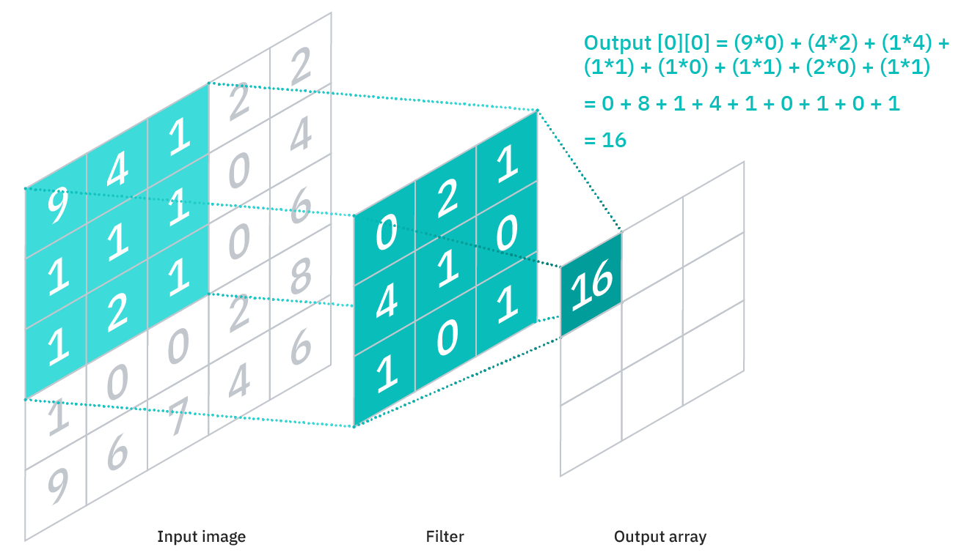

Figure 1: Convolutional layer, adapted from [23]

The recent study from Ortu et. al. [1] shows that the CNN model can achieve the best performance with the unrestricted hourly data model by 87% accuracy and 2.7% of standard deviation. Thus, we decided to use CNN as one of our machine learning models. In this project, the output layer has 3 neurons, which correspond to the buy/hold/sell signal.

As CNN is usually used for processing image data and requires input data of multiple dimensions, to fit the input data in a CNN model, we have transformed input data of each hour into 3 dimensions: ***1*** x ***h*** x ***f***, where ***h*** is the time window length, ***f*** is the number of features. This model was implemented using Keras. The parameters of our CNN model are listed as follows.

|  |  |
| --- | --- |
| Optimizer | Adam, learning rate = 0.0001 |
| Loss function | Categorical cross entropy |
| Number of epochs | 200 |
| Batch size | 32 |
| Layers | |
| Conv1D | Kernel size = 9, padding = “same”, 32 filters |
| BatchNormalization |  |
| Activation | ReLU |
| Conv1D | Kernel size = 5, padding = “same”, 160 filters |
| BatchNormalization |  |
| Activation | ReLU |
| Conv1D | Kernel size = 8, padding = “same”, 224 filters |
| BatchNormalization |  |
| Activation | ReLU |
| Conv1D | Kernel size = 6, padding = “same”, 64 filters |
| BatchNormalization |  |
| Activation | ReLU |
| Flatten |  |
| Dropout | Rate=0.1 |
| Dense | 85 neurons |
| Dense | 75 neurons |
| Dense | 65 neurons |
| Dense | 3 neurons, activation = “softmax” |

Table 2: Parameters of our CNN model

#### 3.7.2 Multilayer Perceptron (MLP)

A multilayer perceptron (MLP) is a feedforward artificial neural network that has multiple layers of perceptions. It consists of three-layer categories: input layer, hidden layer, and output layer. It can learn linear and non-linear relationships through different activation functions and can perform time series forecasting. It is more robust than simple methods like support vector machine (SVM) and k-nearest neighbor (KNN). It is easy to implement and considered as a baseline, so it is adopted as one of our models. The output layer has 3 neurons, which correspond to buy/hold/sell signal. The model was implemented using Scikit-learn. The parameters of our MLP model are listed as follows.

|  |  |
| --- | --- |
| Optimizer | Adam, learning rate = 0.0001 |
| Loss function | Categorical cross entropy |
| Hidden layer sizes | (50, 50, 50) |
| Max number of iterations | 50 |
| Batch size | 64 |

Table 3: Parameters of our MLP model

#### 3.7.3 Long Short-Term Memory (LSTM)

A Long Short-Term Memory (LSTM) is a recurrent neural network (RNN) that is suitable for processing and predicting notable events with relatively long intervals and delays in the time series. Compared with the simple RNN neurons, the neurons of LSTM are much more complex. The input received by each neuron is not only the sample input at the current and previous moments but also a cell state. The structure of an LSTM is shown in Figure 2. It can keep track of long-term dependencies in input data, which solves the problem of vanishing gradient in vanilla RNN [24]. By keeping track of long-term information, it may outperform baseline models like MLP. The output layer has 3 neurons, which correspond to buy/hold/sell signal.

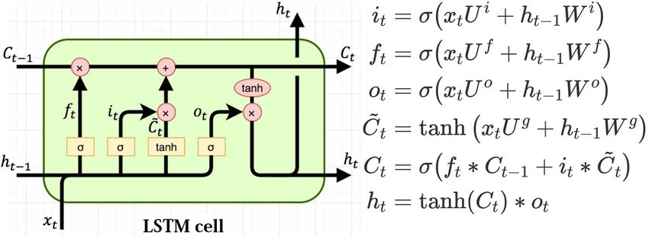

Figure 2: The gates of an LSTM cell, adapted from [25]

To utilize LSTM, we have transformed input data of each hour into 2 dimensions: ***h*** x ***f***, where ***h*** is the time window length, ***f*** is the number of features. The model was implemented using Keras. The parameters of our LSTM model are listed as follows.

|  |  |
| --- | --- |
| Optimizer | Adam, learning rate = 0.0001 |
| Loss function | Categorical cross entropy |
| Batch size | 256 |
| Number of epochs | 20 |
| Layers | |
| LSTM | 50 units, return sequences = True |
| LSTM | 50 units, return sequences = True |
| LSTM | 50 units |
| Dense | 3 neurons, activation = “softmax” |

Table 4: Parameters of our LSTM model

#### 3.7.4 K-Nearest Neighbor (KNN)

A K-Nearest Neighbor (KNN) model is a supervised learning model that uses K closest training examples to predict the class/value of new data by majority voting. It relies on distance measures such as Euclidean distance and cosine similarity measures. It is easy to implement but it may not perform well with high-dimensional data and feature scaling is needed as this model is sensitive to noise. The model was implemented using Scikit-learn. The parameters of our KNN model are listed as follows.

|  |  |
| --- | --- |
| K (Number of neighbors) | 7 |
| Weight function | Uniform |
| Distance metric | Minkowski |

Table 5: Parameters of our KNN model

#### 3.7.5 Random Forest (RF)

A Random Forest (RF) consists of multiple decision trees that work as an ensemble. Each tree in the ensemble outputs a class prediction and the class with the highest number of votes becomes the output of the ensemble. The depth and the split conditions of trees can be set and reduce the chance of overfitting. The more trees in the forest the more robust the model is. A large collection of de-correlated trees can have a better predictive power than an individual model [26]. As the input data has been fed to PCA, the components generated have no correlations with each other, thus the individual trees are likely to have low correlations with each other. The model was implemented using Scikit-learn. The parameters of our RF model are listed as follows.

|  |  |
| --- | --- |
| Number of estimators | 100 |
| Max number of features | None (no restrictions) |
| Criterion | Gini impurity |

Table 6: Parameters of our RF model

#### 3.7.6 XGBoost (XGB)

XGBoost is short for “eXtreme Gradient Boosting” and “eXtreme” refers to its enhancements such as parallel computing and cache awareness that makes XGBoost approximately 10 times faster than the traditional Gradient Boosting method [27]. Boosting is different from bagging (which is used in Random Forest). Instead of aggregating predictions, boosters turn weak learners into strong learners by focusing on training examples that are hard to classify. Then the weak learners learn from misclassified training examples each boosting round to improve the performance of the ensemble. The model was implemented using the Python library xgboost. The parameters of our XGB model are listed as follows.

|  |  |
| --- | --- |
| Booster | GBTree |
| Learning rate | 0.1 |
| Number of estimators | 50 |

Table 7: Parameters of our XGB model

#### 3.7.7 Simple Moving Average (SMA) model

Regarding trading the ETH futures with the traditional trading model, we are firstly to implement the well-known and commonly used technical trading rule, which is Simple Moving Average (SMA), to generates trading signals by employing a short-period and a long-period moving average of the price. The idea behind moving average is to identify the trend of the price movement.

By theory, SMA is an arithmetic moving average calculated by adding recent prices and then dividing that figure by the number of periods in the calculation average. The formula is as follows:

$$SMA_{n }= \frac{A_{1} + A_{2} + … +A_{n}}{n}$$

were $A_{i}$ = the price of an asset at period $i$, and $n$ = the number of hours used to calculate the short-term and long-term moving average. Different n indicates different strategies implemented under the SMA trading rule. Using the long and short moving averages, we will simply take the investment decision according to the buy/sell signal as below:

Buy signal = if Short MA – Long MA > 0, then we would buy Ethereum Futures.

Sell signal = if Short MA – Long MA < 0, then we would sell Ethereum Futures.

Simply speaking, whenever the short-period moving average crosses over the long-period moving average, we would identify it as a rising trend and we will buy and hold until the next counter trading signal existed, and vice versa.

At the first hour with moving average value, if short MA line is above the long MA line, then it is regarded as a buy signal directly, and hold a long position of ETH futures contract immediately. If the short MA line is below the long MA line, then it is regarded as a sell signal directly, and holds a short position of ETH futures contract immediately.

First 5000 data points were used as training dataset, and 5001 to 13909 were used as testing dataset. In the training dataset, we would find the most appropriate combination of short-term MA and long-term MA in terms of (1) Sharpe ratio, (2) Total return and (3) Maximum drawdown by trial-and-error method and apply it on testing dataset accordingly.

For the short-term MA, we prefer to choose the hour as short as possible and for the long-term MA, we prefer to choose the hour as long as possible. Different combinations of short-term period and long-term period were tested. For the detail, please refer to Figure A.1 to 3.

On the testing dataset, we would apply the most appropriate combination from the training dataset and use the respective close price as our enter and exit price. There is no fractional trade (i.e., position size is an integer).

In the SMA model, we would mainly use the (1) Sharpe ratio, (2) Total return and (3) Maximum drawdown to evaluate the performance of the model.

#### 3.7.8 Simple Moving Average (SMA) plus Bollinger Band (BB) model

Simple Moving Average (SMA) plus Bollinger Band (BB) model is an advanced strategy which added the BB into SMA. The idea is to generate trading signals by creating a trading channel with the upper and lower band. Also, the upper and lower bands are our buffer to reduce the trading frequency.

The formulas of BBs are as below (3 Std for calculating BBs):

$$Variance=\frac{\sum_{ }^{ }{\left(X-SMA_{n}\right)}}{n}$$

$$Std=\sqrt{Variance}$$

$$Upper band ={Average Close}_{n}+\left(3×Std\right)$$

$$Lower band ={Average Close}_{n}-\left(3×Std\right)$$

The trading rules are as below:

Buy signal = SMA line rises above the lower range of BB

Sell signal = SMA line falls below the upper range of BB

Simply speaking, whenever the simple moving average curve crosses over the lower band, we would identify it as a rising trend and we will buy and hold until the next counter trading signal existed, and vice versa.

At the first hour with moving average value, if SMA line is above the lower band, then it is regarded as a buy signal directly, and hold a long position of ETH futures contract immediately. If SMA line above the upper band, then it is regarded as a sell signal directly, and hold a short position of ETH futures contract immediately.

First 5000 data points were used as training dataset, and 5001 to 13909 were used as testing dataset. In the training dataset, we would find the best combination of moving average and Bollinger Band by trial-and-error method and apply it on testing dataset accordingly. Different combinations of moving average and Bollinger Band were tested. For the detail, please refer to Figure A.4 to 6.

In the training dataset, we would find the most appropriate combination of moving average and Bollinger Band by trial-and-error method and apply it on testing dataset accordingly. For the moving average, as a further developed model from SMA, we would first give priority to choose the hour (i.e. 90 hours) which we have chosen on SMA model, and for the Bollinger Band, we would find the best combination in terms of (1) Sharpe ratio, (2) Total return and (3) Maximum drawdown.

On the testing dataset, similar to SMA model above, we would apply the chosen combination from training dataset and use the respective close price as our enter and exit price. There is no fractional trade (i.e., position size is an integer).

In the SMA plus BB model, we would mainly use the (1) Total return, (2) Sharpe ratio and (3) Maximum drawdown to evaluate the performance of the model.

#### 3.7.9 Combined model

The aforementioned 8 models are combined to work as an ensemble. Each model in the ensemble outputs a class prediction and the class with the highest number of votes becomes the output of the combined model. When two classes have the same number of votes (e.g., 3 buy, 3 sell, 2 hold), a hold signal becomes the output because the models are confident about what signals to output. The performance of the combined model was tested and compared to individual models.

### 3.8 Machine learning models for sentiment analysis

We picked 3 language models to generate social media indicators instead of just using one model because of the “wisdom of crowds”. The first and the third model have 3 labels representing positive, negative, and neutral. The second model has 13 labels each corresponding to a type of emotion.

#### 3.8.1 Twitter-roBERTa-base-latest for sentiment analysis

Twitter-roBERTa-base is a roBERTa model trained on about 124 million tweets from January 2018 to December 2021 [28] and it is finetuned for sentiment analysis. This model takes a tweet as input and outputs 3 values corresponding to the probabilities of the tweet being negative, neutral, and positive.

In this project, this model is used as the first language model for outputting the positive score, negative score, and neutral score for each data point in ETH futures pricing data. After we collected tweets using a scraping tool and grouped them by the hour, we processed them as below:

1. Lower-case all words
2. Remove words starting with “#” (hashtag) and “@”
3. Remove websites starting with “www” or “http”
4. Remove some punctuation such as “.”, “?” and “!”
5. Remove non-alphanumeric characters
6. Correct misspelled words using a misspelled word list
7. Expand contractions, e.g., expand “you’re” to “you are”

Then these tweets were fed to this model. Every tweet has a negative score, neutral score, and positive score. For tweets in the same hour, their positive scores, negative scores, and neutral scores were summed up individually and divided by number of tweets. So, the output for the 3 scores in an hour will be the average of positive scores, negative scores, and neutral scores for all tweets in that hour. And the sum of the 3 scores in any hour is always 1.

#### 3.8.2 roBERTa-base trained with emotion dataset

The second language model is based on a pre-trained roBERTa-base model, and we further trained it on an Emotion dataset found on Kaggle [29]. The dataset contains 40000 tweets, and each tweet has a label of emotion. There are 13 emotion labels in total: empty, sadness, enthusiasm, neutral, worry, surprise, love, fun, hate, happiness, boredom, relief, and anger. We trained the model with batch size = 16 and 3 epochs. Because the trained model can output the probabilities of 13 emotions, it might give more information than a model that simply outputs 3 scores corresponding to positive, neutral, and negative. We processed the tweets as below:

1. Lower-case all words
2. “Demojize”: replace Unicode emoji in a string with emoji short codes
3. Remove words starting with “#” (hashtag), “0x” (EVM-compatible wallet/smart contract address), and “$” (fiat or cryptocurrency symbol)
4. Remove contiguous words that are repeated, e.g., “happy happy” is transformed to “happy”
5. Remove numbers
6. Remove websites starting with “www” or “http”
7. Remove some punctuation such as “.”, “?” and “!”

Then these tweets were fed to this model. Every tweet has 13 emotion scores. Like the processing of the first model, the output for the 13 scores in an hour will be the average of these scores for all tweets in that hour.

#### 3.8.3 CryptoBERT

CryptoBERT is a pre-trained NLP model specifically for analyzing the sentiments of cryptocurrency-related social media posts and messages [30]. It is also based on a pre-trained roBERTa-base model, and further fine-tuned on a balanced dataset of 2 million labeled StockTwits posts from 1 November 2021 to 16 June 2022. The model outputs 3 labels: bearish, neutral, and bullish. The processing steps are the same as the steps of the first language model.

### 3.9 Result evaluation

We will compare our models’ return with this buy and hold return. For backtesting, short selling is allowed. The initial equity is 1 million dollars. Orders are filled with respect to the next bar's opening price. The backtesting framework does not do fractional trade, i.e., position size is always integer.

In general, we would use several common performance measures (i.e. Total return, Sharpe ratio and Maximum drawdown) to evaluate each models made by machine learning and traditional financial techniques.

For those machine learning models, we would further evaluate them using confusion matrix (i.e. accuracy, precision, recall, F1 score).

By using multiple measures, we have a broader view of assessing the different perspectives of the performance of the models, for example, sometimes a high accuracy model may be based on some classification.

Multiple settings of backtesting were tested as described in Table 10.

|  |  |
| --- | --- |
| Parameter | Values |
| Transaction fee | 1. 0% 2. 0.05% 3. 0.2% |
| Lag window for social media indicators | 1 hour |

Table 8: Multiple settings of backtesting that were tested

# 4. Results

### 4.1 Performance of buy and hold

We have collected the following result from the buy and hold strategy for referencing.

|  |  |  |  |  |  |  |  |  |  |  |
| --- | --- | --- | --- | --- | --- | --- | --- | --- | --- | --- |
| **Class** | | | | | | | | | | |
| “Buy” (1) | | | “Sell” (-1) | | | “Hold” (0) | | | **Macro F1**  **score** | **Accuracy** |
| **Precision** | **Recall** | **F1** | **Precision** | **Recall** | **F1** | **Precision** | **Recall** | **F1** |
| 0 | 0 | 0 | 0 | 0 | 0 | 0.43 | 1 | 0.6 | 0.2 | 0.43 |

Table 9: Confusion matrix of Buy and Hold

|  |  |  |  |  |  |  |  |
| --- | --- | --- | --- | --- | --- | --- | --- |
|  | Return | Sharpe Ratio | Sortino Ratio | Max. Drawdown | Win Rate | #Trade | |
| Original | 45.79% | 0.87 | 0.49 | -60.2% | 100% | 1 |
| With 0.05% fee | 45.65% | 0.87 | 0.49 | -60.17% | 100% | 1 |
| With 0.2% fee | 45.5% | 0.87 | 0.49 | -60.2% | 100% | 1 |

Table 10: P/L statistics of Buy and Hold with different trading fees

Since buy and hold only executed 1 trade. Most of the time it is holding the position, therefore, only Hold class has better predicting performance than Buy and Sell. The accuracy of Buy and Hold is 43% and the macro F1 score is 20%. The total return is around 45%. The Sharpe ratio is 0.87 and the maximum drawdown is -60.2%

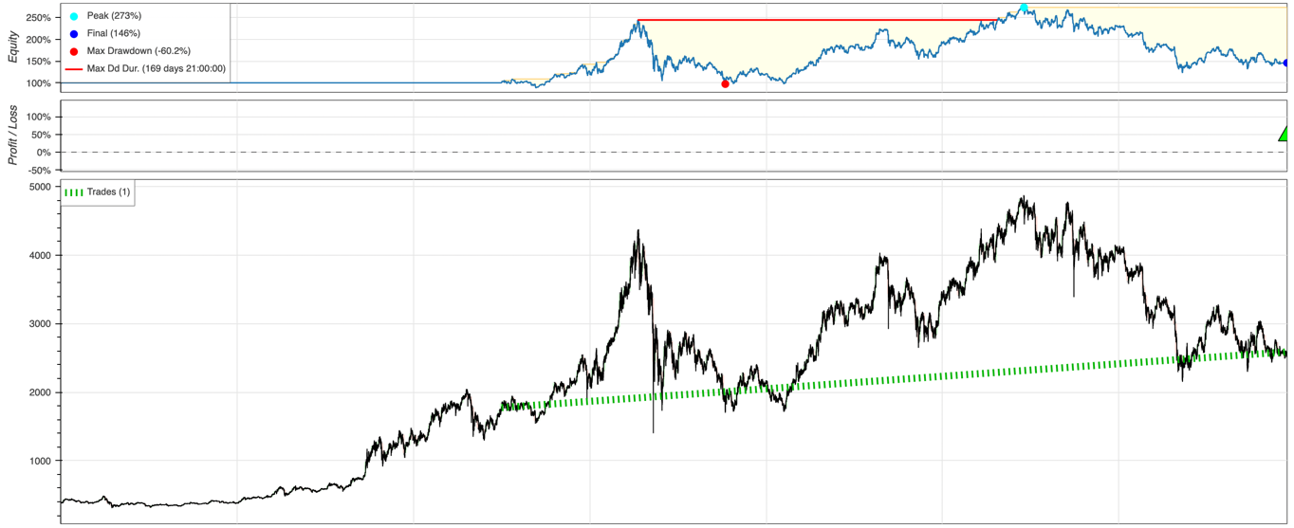

Figure 3: Equity curve of Buy and Hold

Figure 3 is the equity curve of Buy and hold. As we used the first 4999 records for the training dataset, we buy in 5001 and then sell it in the last trading window. The movement of equity curve is following the market trend.

### 4.2 Performance of MLP

|  |  |  |  |  |  |  |  |  |  |  |
| --- | --- | --- | --- | --- | --- | --- | --- | --- | --- | --- |
| **Class** | | | | | | | | | | |
| “Buy” (1) | | | “Sell” (-1) | | | “Hold” (0) | | | **Macro F1**  **score** | **Accuracy** |
| **Precision** | **Recall** | **F1** | **Precision** | **Recall** | **F1** | **Precision** | **Recall** | **F1** |
| 0.33 | 0.34 | 0.34 | 0.29 | 0.29 | 0.29 | 0.47 | 0.46 | 0.46 | 0.36 | 0.38 |

Table 11: Confusion matrix of MLP model

|  |  |  |  |  |  |  |  |
| --- | --- | --- | --- | --- | --- | --- | --- |
|  | Return | Sharpe Ratio | Sortino Ratio | Max. Drawdown | Win Rate | #Trade | |
| Original | 39.95% | 0.811 | 0.58 | -52.46% | 52.23% | | 1534 |
| With 0.05% fee | -35.01% | -0.09 | 0 | -61.55% | 50.13% | | 1534 |
| With 0.2% fee | -93.35% | -2.77 | 0 | -94.06% | 45.96% | | 1534 |

Table 12: P/L statistics of MLP model with different trading fees

Table 13 is the confusion matrix of multilayer perceptron model. It archived 38% accuracy and 36% macro F1 score. It is slightly better than random trade (33% accuracy rate). Also. The MLP model performed better in predicting Hold class (46% F1 score) than predicting Buy (34% F1 score) and Sell (29% F1 score) classes. That is because 43% of our dataset is Hold class which is largest population, and the model tends to predict Hold class.

Table 14 is the P/L statistic of the MLP model. It executed 1534 trades from March 2021 to March 20222. When there is no trading fee, our MLP model can gain 39.95% profit. The Sharpe ratio is 0.811 which is not a satisfactory result. Sharpe ratio is one of the critical indicators to measure strategy stability and performance by considering both return and risk. In this case, the Sharpe rate of 0.811 represents that under the risk of 1% fluctuation, it can create a return rate of 0.811% overall. Also, this run’s maximum drawdown is -52.46%. Maximum drawdown indicator is also important to evaluate the greatest risk the strategy may face. When the trading fee increases to 0.05% and 0.2%, the results of all indicators are bad. For testing with a trading fee of 0.05%, it can lose 35.01% in total. The Sharpe ratio dropped significantly to -0.09 and the maximum drawdown is -61.55%. Testing with a trading fee of 0.2%, further increases the loss to 93.35%. The Sharpe also falls to -2.77 and the maximum drawdown is -94.06%. These results reflect our MLP model is better than random trade but worse than Buy and Hold, it can only gain small profit with medium risk from March 2021 to March 2022 when there is no trading fee.

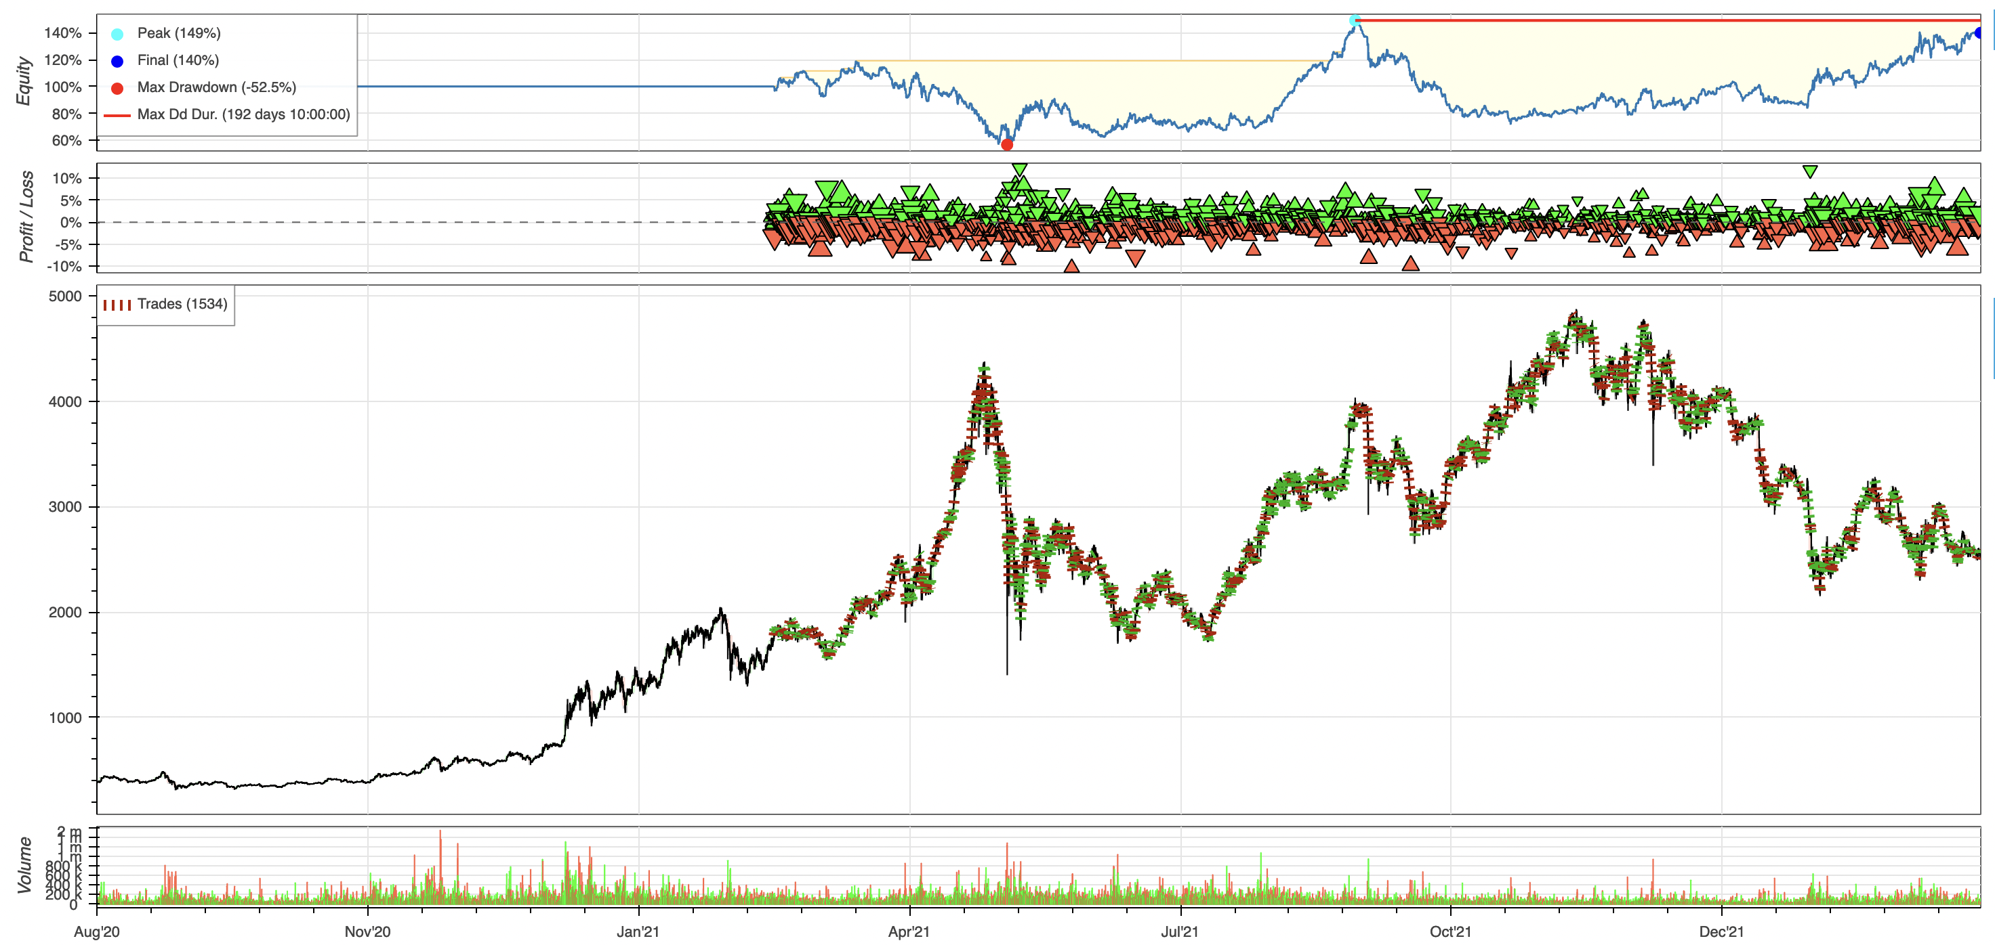

Figure 4: Equity curve of MLP

Figure 4 is the equity curve of MLP. When comparing it with the market movement, we could find that the equity curve drops in the early stage, especially in the period of the first market dropdown. But then, the equity curve turns to an uptrend. It may be because the market fell sharply for the first time, it has not appeared in the past so there is no relevant learning data and pattern that can be studied by the model.

### 4.2 Performance of KNN

|  |  |  |  |  |  |  |  |  |  |  |
| --- | --- | --- | --- | --- | --- | --- | --- | --- | --- | --- |
| **Class** | | | | | | | | | | |
| “Buy” (1) | | | “Sell” (-1) | | | “Hold” (0) | | | **Macro F1**  **score** | **Accuracy** |
| **Precision** | **Recall** | **F1** | **Precision** | **Recall** | **F1** | **Precision** | **Recall** | **F1** |
| 0.34 | 0.23 | 0.27 | 0.29 | 0.27 | 0.28 | 0.46 | 0.58 | 0.51 | 0.35 | 0.39 |

Table 13: Confusion matrix of KNN model

|  |  |  |  |  |  |  |  |
| --- | --- | --- | --- | --- | --- | --- | --- |
|  | Return | Sharpe Ratio | Sortino Ratio | Max. Drawdown | Win Rate | #Trade | |
| Original | 4.79% | 0.55 | 0.06 | -59.67% | 53.22% | 1804 |
| With 0.05% fee | -57.47% | -0.35 | 0 | -74.19% | 50.94% | 1804 |
| With 0.2% fee | -97.01% | -3 | 0 | -97.14% | 46.84% | 1804 |

Table 14: P/L statistics of KNN model with different trading fees

Table 15 is the confusion matrix of the k-nearest neighbors model. It archived 39% accuracy and 35% macro F1 score which is slightly better than random trade with 33% accuracy. The performance of each prediction class is close to the MLP model. Performance of predicting Hold class (51% F1 score) is better than Buy (27% F1 score) and Sell (28% F1 score) classes.

Table 16 is the P/L statistic of the KNN model. It executed 1804 trades from March 2021 to March 2022. When there is no trading fee, our KNN model can gain 4.79% profit. The Sharpe ratio is 0.55 and the maximum drawdown is -59.67%. When the trading fee increases to 0.05% and 0.2%, the indicators become even worse. For testing with a trading fee of 0.05%, it can lose 57.47%. The Sharpe ratio has dropped to -0.35 and the maximum drawdown is -74.19%. Testing with a trading fee of 0.2%, further increases the loss to 97.01%. The Sharpe ratio falls to -3 with the maximum drawdown of -97.14%.

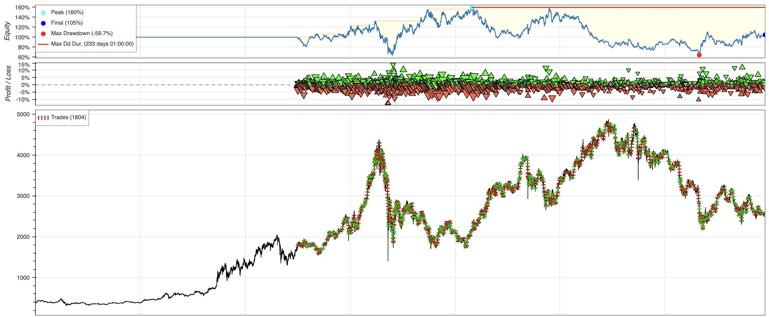

Figure 5: Equity curve of KNN

Figure 5 is the equity curve of KNN. When comparing it with market movement, we could find that there is a correlation throughout the trading period. When the market is up, our equity curve is also up. When the market is down, our equity curve is also down.

### 4.3 Performance of LSTM

|  |  |  |  |  |  |  |  |  |  |  |
| --- | --- | --- | --- | --- | --- | --- | --- | --- | --- | --- |
| **Class** | | | | | | | | | | |
| “Buy” (1) | | | “Sell” (-1) | | | “Hold” (0) | | | **Macro F1**  **score** | **Accuracy** |
| **Precision** | **Recall** | **F1** | **Precision** | **Recall** | **F1** | **Precision** | **Recall** | **F1** |
| 0.32 | 0.3 | 0.31 | 0.28 | 0.3 | 0.29 | 0.47 | 0.47 | 0.47 | 0.36 | 0.37 |

Table 15: Confusion matrix of LSTM model

|  |  |  |  |  |  |  |  |
| --- | --- | --- | --- | --- | --- | --- | --- |
|  | Return | Sharpe Ratio | Sortino Ratio | Max. Drawdown | Win Rate | #Trade | |
| Original | 156.84% | 1.424 | 1.55 | -73.8% | 52.02% | 1136 |
| With 0.05% fee | 45.69% | 0.86 | 0.23 | -78.15% | 50.18% | 1136 |
| With 0.2% fee | -73.54% | -0.81 | 0 | -89.22% | 45.77% | 1136 |

Table 16: P/L statistics of LSTM model with different trading fees

Table 17 is the confusion matrix of the Long short-term memory model. It archived 37% accuracy and 36% macro F1 score which is slightly better than random trade with 33% accuracy. The performance of each prediction class is close to MLP and KNN models. The performance of predicting Hold class (47% F1 score) is better than Buy (31 % F1 score) and Sell (29% F1 score) classes.

Table 18 is the P/L statistic of the LSTM model. It executed 1136 trades from March 2021 to March 2022. When there is no trading fee, our LSTM model can gain 156.84% profit. The Sharpe ratio is 1.424 and the maximum drawdown is -73.8%. When the trading fee increases to 0.05%, the total return is reduced to 45.69% becomes 26.57%. Also, the Sharpe ratio falls to 0.23 with the maximum drawdown of -78.15%. When the trading fee further increases to 0.2%, our model loses 73.54%. The Sharpe ratio drops significantly to -0.81.

As we can see, our LSTM performs well when there is no trading cost. However, the performance of having a small trading fee is not acceptable given that it has a positive return. It is because its Sharpe ratio < 1 which means having risk.

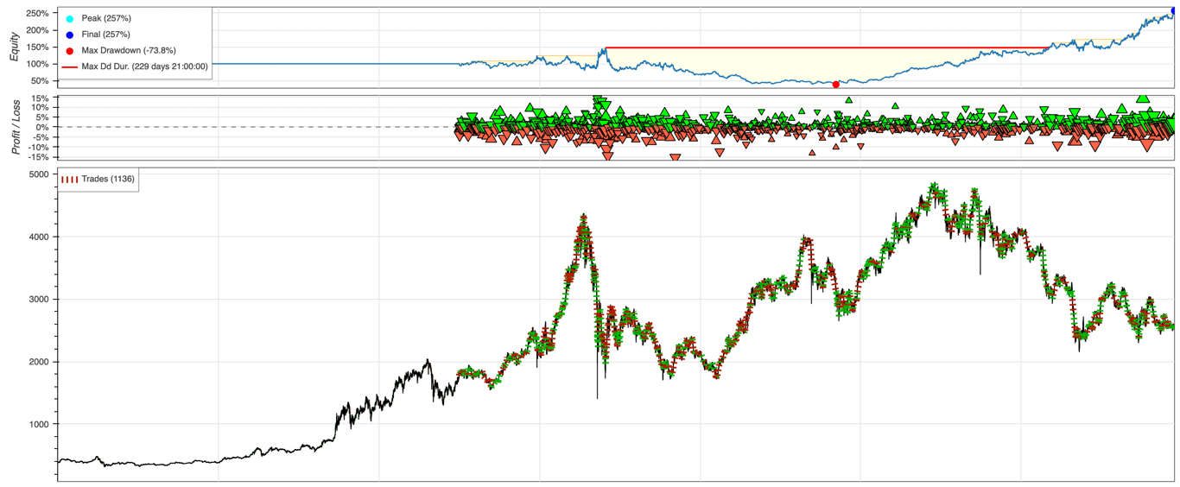

Figure 6: Equity curve of LSTM

Figure 6 is the equity curve of LSTM. When comparing it with market movement, we could find that the equity curve went down following the first market drawdown between May 2021 and July 2021, then the equity curve turns to a stable uptrend to the end.

### 4.4 Performance of RF

|  |  |  |  |  |  |  |  |  |  |  |
| --- | --- | --- | --- | --- | --- | --- | --- | --- | --- | --- |
| **Class** | | | | | | | | | | |
| “Buy” (1) | | | “Sell” (-1) | | | “Hold” (0) | | | **Macro F1**  **score** | **Accuracy** |
| **Precision** | **Recall** | **F1** | **Precision** | **Recall** | **F1** | **Precision** | **Recall** | **F1** |
| 0.34 | 0.3 | 0.32 | 0.32 | 0.15 | 0.2 | 0.48 | 0.69 | 0.56 | 0.36 | 0.42 |

Table 17: Confusion matrix of RF model

|  |  |  |  |  |  |  |  |
| --- | --- | --- | --- | --- | --- | --- | --- |
|  | Return | Sharpe Ratio | Sortino Ratio | Max. Drawdown | Win Rate | #Trade | |
| Original | 154.59% | 1.42 | 1.456 | -61.4% | 54.98% | 1366 |
| With 0.05% fee | 28.67% | 0.75 | 0.3 | -66.98% | 53.51% | 1366 |
| With 0.2% fee | -83.37% | -1.27 | 0 | -92.4% | 50% | 1366 |

Table 18: P/L statistics of RF model with different trading fees

Table 19 is the confusion matrix of the Random forests model. It archived 42% acracy and 36% of macro F1 score which is better than random trade's 33% accuracy. The performance of predicting Hold class is far better than Buy and Sell. Hold class has 56% F1 score while Buy and Sell have 32% and 20% macro F1 score.

Table 20 is the P/L statistic of the RF model. It executed 1366 trades from March 2021 to March 2022. When there is no trading fee, our RF model can gain 154.59% profit. The Sharpe ratio is 1.456 and the maximum drawdown is 54.98%. When the trading fee increases to 0.05%, the total return drops to 28.67%. Also, the Sharpe ratio falls to 0.75 with -66.98% of maximum drawdown. When the trading fee further increases to 0.2%, our model loses 83.37%. The Sharpe ratio drops significantly to -1.27.

In conclusion, the RF model’s performance is similar to the LSTM model. It performed well when there was no trading fee. However, the model with minimal cost is not acceptable although it can also generate a positive gain. That is because the Sharpe ratio is < 1 which means there is a potential risk.

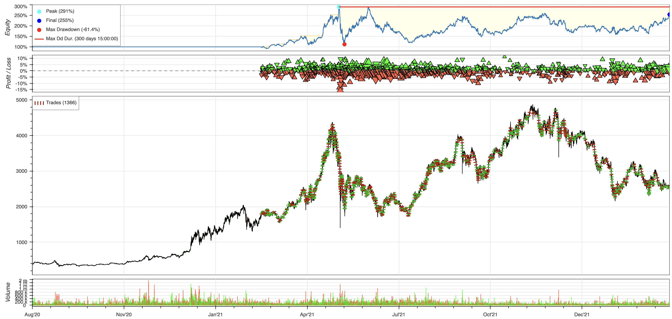

Figure 7: Equity curve of RF

Figure 7 is the equity of RF model. When comparing it with market movement, both equity curve and market movement are highly volatile. The trend of equity curve is correlated with market movement.

### 4.5 Performance of XGB

|  |  |  |  |  |  |  |  |  |  |  |
| --- | --- | --- | --- | --- | --- | --- | --- | --- | --- | --- |
| **Class** | | | | | | | | | | |
| “Buy” (1) | | | “Sell” (-1) | | | “Hold” (0) | | | **Macro F1**  **score** | **Accuracy** |
| **Precision** | **Recall** | **F1** | **Precision** | **Recall** | **F1** | **Precision** | **Recall** | **F1** |
| 0.34 | 0.29 | 0.31 | 0.31 | 0.21 | 0.25 | 0.48 | 0.63 | 0.55 | 0.37 | 0.42 |

Table 19: Confusion matrix of XGB model

|  |  |  |  |  |  |  |  |
| --- | --- | --- | --- | --- | --- | --- | --- |
|  | Return | Sharpe Ratio | Sortino Ratio | Max. Drawdown | Win Rate | #Trade | |
| Original | 37.87% | 0.81 | 0.41 | -60.34% | 53.57% | 1738 |
| With 0.05% fee | -42.11% | -0.04 | 0 | -70.02% | 52.47% | 1738 |
| With 0.2% fee | -95.63% | -2.6 | 0 | -96.48% | 47.99% | 1738 |

Table 20: P/L statistics of XGB model with different trading fees

Table 21 is the confusion matrix of the XGBoost model. It archived 42% accuracy and 37% macro F1 score which is better than random trade with 33% of accuracy. The XGB model performed well in predicting Hold class then Buy and Sell classes. Hold class has 55% of F1 score while Buy and Sell have 31% F1 score and 25% F1 score, respectively.

Table 22 is the P/L statistic of the XGB model. It executed 1738 trades from March 2021 to March 2022. When there is no trading fee, our XGB model can gain 37.87% profit. The Sharpe ratio is 0.81 and the maximum drawdown is 60.34%. When the trading fee increases to 0.05% and 0.2%, the return and Sharpe ratio become negative. For testing with a trading fee 0.0.5%, it can lose 42.11%. The Sharpe ratio has dropped to -0.04 and the maximum drawdown is -70.02%. Testing with a trading fee of 0.2%, further increased the loss to 95.63%. The Sharpe ratio falls to -2.6 with the maximum drawdown of -96.48%.

As we can see, whether have trading fee or not, the Sharpe ratio of these tests is less than 1. Hence, we consider the performance of all tests to be bad.

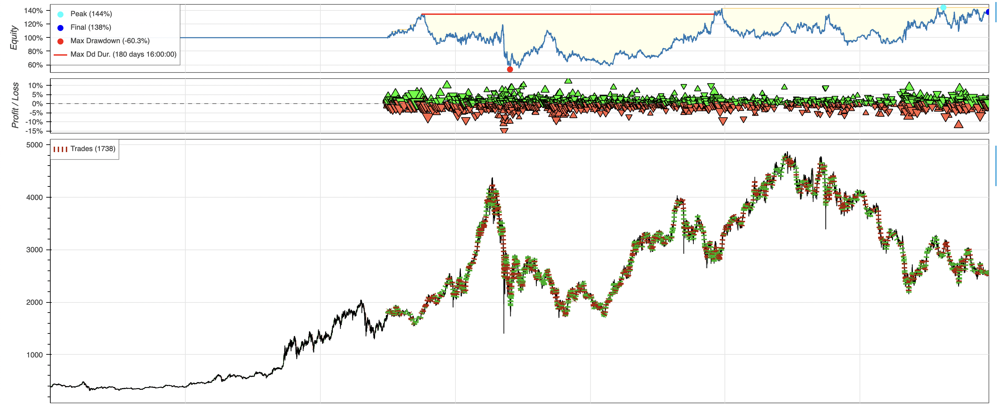

Figure 8: Equity curve of XGB

Figure 8 is the equity curve of XGB. When comparing it with market movement, we could see the XGB model performed badly in the first half of the testing dataset, the equity curve went down even though the price was increasing. But then, in the second half of the testing dataset, it performed well, the equity curve steadily went up when the price went down.

### 4.6 Performance of CNN

|  |  |  |  |  |  |  |  |  |  |  |
| --- | --- | --- | --- | --- | --- | --- | --- | --- | --- | --- |
| **Class** | | | | | | | | | | |
| “Buy” (1) | | | “Sell” (2) | | | “Hold” (0) | | | **Macro F1**  **score** | **Accuracy** |
| **Precision** | **Recall** | **F1** | **Precision** | **Recall** | **F1** | **Precision** | **Recall** | **F1** |
| 0.32 | 0.31 | 0.31 | 0.3 | 0.27 | 0.28 | 0.46 | 0.5 | 0.48 | 0.37 | 0.39 |

Table 21: Confusion matrix of CNN model

|  |  |  |  |  |  |  |  |
| --- | --- | --- | --- | --- | --- | --- | --- |
|  | Return | Sharpe Ratio | Sortino Ratio | Max. Drawdown | Win Rate | #Trade | |
| Original | 482.89% | 2.25 | 4.09 | -47.74% | 52.27% | 1961 |
| With 0.05% fee | 118.7% | 1.27 | 1.23 | -54.63% | 50.59% | 1961 |
| With 0.2% fee | -88.29% | -1.63 | 0 | -90.16% | 45.95% | 1961 |

Table 22: P/L statistics of CNN model with different trading fees

Table 23 is the confusion matrix of the convolutional neural network model. It archived 39% accuracy and 37% macro F1 score which is slightly better than random trade with 33% of accuracy. Similar to other models, the CNN model performed well in predicting Hold class then Buy and Sell classes. The F1 score of predicting Hold class is 48% while Buy and Sell classes have 31% and 28% respectively.

Table 24 is the P/L statistic of the CNN model. It executed 1961 trades from March 2021 to March 2022. Surprisingly, the CNN model got incredibly satisfactory results. When there is no trading fee, our CNN model can gain 424.89% profit. The Sharpe ratio is 2.25 and the maximum drawdown is -47.74%. When the trading fee increases to 0.05%, our CNN model can gain 118.7%. The Sharpe ratio is 1.27 and the maximum drawdown is -54.63%. That makes sense since the number of trades is the same as the test with no fee but the cost per trade increased. When testing with a trading fee of 0.2%, the return and Sharpe ratio becomes negative. Our CNN model lost 88.29%. The Sharpe ratio falls to -1.63 and the maximum drawdown to -90.16%. In conclusion, CNN performed well when there was no minimal trading fee.

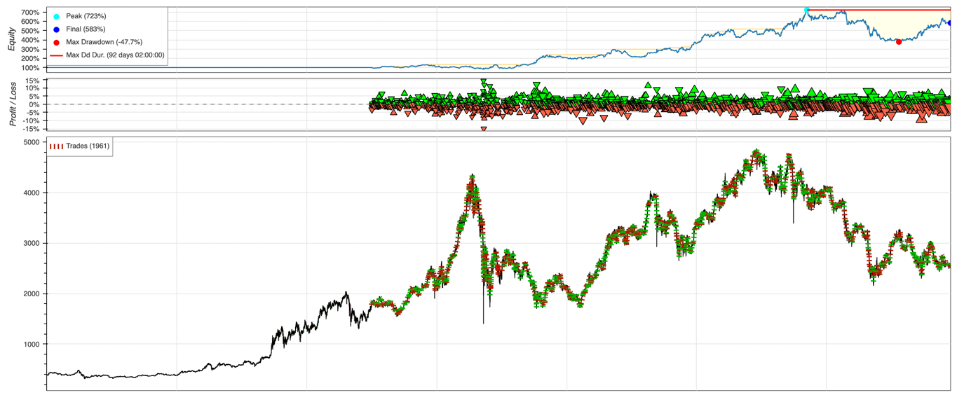

Figure 9: Equity curve of CNN

Figure 9 is the equity curve of CNN model. When comparing it with market movement, we could find that the equity curve growth steadily with low volatile even though there was a large dropdown in the market. It is obviously a good model.

### 4.7 Performance of SMA

With reference to the training dataset result (Figure A.1 - 3), we find some meaningful insight. If we set 1 hour as our short-term MA, we would have a good Sharpe ratio on any combination of long-term MA.

In terms of (1) Sharpe ratio, (2) Total return and (3) Maximum drawdown, we considered that setting 1 hour as the short-term MA and 90 hour as long-term MA (i.e Combination (1, 90)) are most appropriate for our testing purpose.

Below is the graph of both equity curve of SMA and market movement of ETH futures. When comparing the equity curve of SMA with the market movement, we could find that the volatility of market movement is much higher than the equity curve of SMA.

This is because of the characteristics of the SMA strategy. The SMA strategy can help to identify the price trend effectively and then buy or sell/ short at the right time.

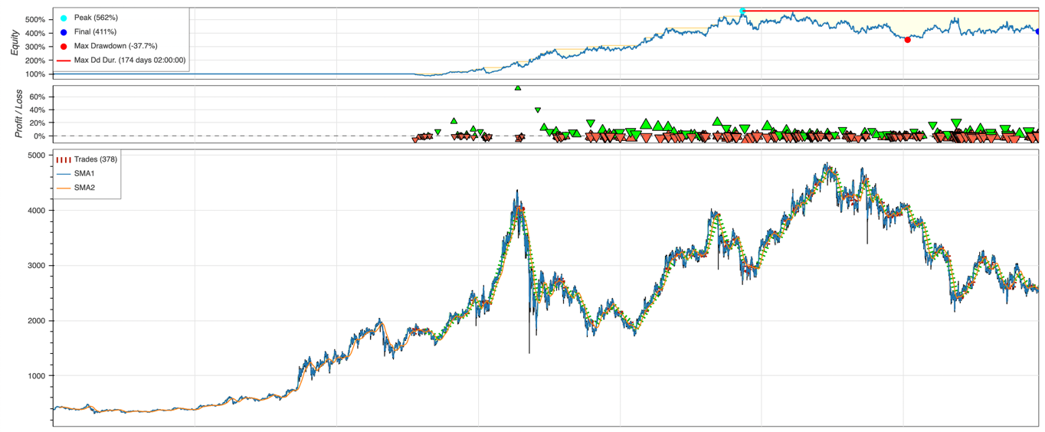

Figure 10: Equity curve of SMA

|  |  |  |  |  |  |  |  |
| --- | --- | --- | --- | --- | --- | --- | --- |
|  | Return | Sharpe Ratio | Sortino Ratio | Max. Drawdown | Win Rate | #Trade | |
| Original | 310.97% | 2.04 | 3.49 | -37.72% | 21.96% | 378 |
| With 0.05% fee | 240.24% | 1.82 | 2.77 | -42.07% | 21.16% | 378 |
| With 0.2% fee | 93.27% | 1.18 | 1.15 | -54.76% | 19.05% | 378 |

Table 23: P/L statistics of SMA model with different trading fees

Table 25 is the P/L statistic of the SMA model. During the testing period from March 2021 to March 2022, 378 trades were recorded. In the table, we have summarized 3 different scenarios with several different key performance indicators.

Under the trading environment without any transaction fee, the SMA model can gain (1) Total return of 310.97%, (2) Sharpe ratio of 2.04, and (3) Maximum drawdown of -37.72%.

Under the trading environment with 0.05% fee, the SMA model can gain (1) Total return of 240.24%, (2) Sharpe ratio of 1.82, and (3) Maximum drawdown of -42.07%.

Under the trading environment with 0.2% fee, the SMA model can gain (1) Total return of 93.27%, (2) Sharpe ratio of 1.18, and (3) Maximum drawdown of -52.76%.

As we can see above, no matter whether adding transaction costs or not, SMA can also perform well compared to our benchmark - Buy and Hold strategy. However, after adding the transaction costs, it would also eat into our profit significantly due to the high trading frequency.

### 4.8 Performance of SMA plus BB

In order to minimize the effect of transaction costs, we therefore develop our SMA model by imposing the Bollinger bands (BB) in order to reduce our trading frequency. We used the Bollinger bands as our trading buffer, which would create a trading channel with the upper and lower band.

Similar with the SMA, we would apply the SMA plus BB strategy on training dataset first, and then find the most appropriate combination for our testing purpose. Setting 90 hours as our MA and 60 hours for calculating the Bollinger bands (i.e., Combination (90, 60)) is considered as most appropriate. (Figure A.4 - 6)

Below is the graph of both equity curve of SMA plus BB strategy and market movement of ETH future. When compared the equity curve of SMA with the market movement, we could find that at the early trading period from 12 March 2021 to 28 November 2021, both equity curves of SMA plus BB strategy and the market movement of ETH futures contract are consistent because we hold a long position of ETH futures contract until 28 November 2021.

On 28 November 2021, the equity curve of SMA plus BB strategy and the market movement of ETH futures contract were moving in the opposite direction because we hold a short position when the market trend was going down.

As we can see in the graph, SMA plus BB strategy is much more effective to identify the long-term trend when compared to SMA strategy. It can help to avoid a long-term downtrend and reduce the trading frequency successfully.

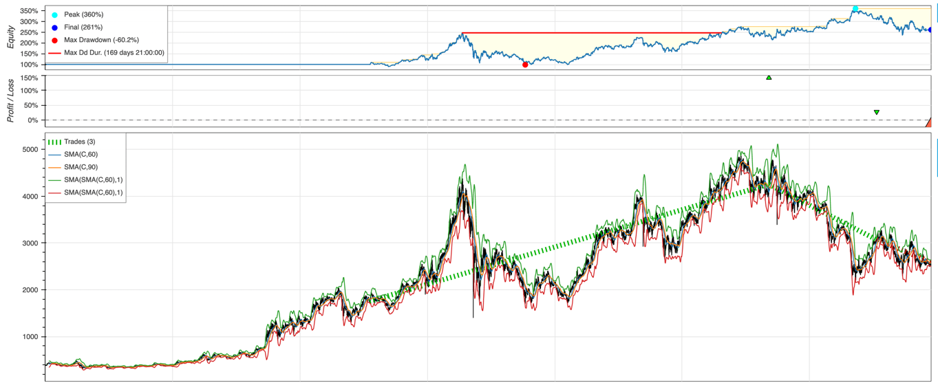

Figure 11: Equity curve of SMA with Bolling band

|  |  |  |  |  |  |  |
| --- | --- | --- | --- | --- | --- | --- |
|  | Return | Sharpe Ratio | Sortino Ratio | Max. Drawdown | Win Rate | #Trade |
| Original | 160.86% | 1.47 | 1.63 | -60.20% | 66.66% | 3 |
| With 0.05% fee | 160.59% | 1.47 | 1.63 | -60.20% | 66.66% | 3 |
| With 0.2% fee | 159.56% | 1.47 | 1.62 | -60.19% | 66.66% | 3 |

Table 24: P/L statistic of SMA with BB model with different trading fees

Table 26 is the P/L statistic of the SMA plus BB model. During the testing period from March 2021 to March 2022, we successfully reduce the trading frequency from 378 to 3, at the same time, we maintain a good return, Sharpe ratio and Maximum drawdown. In the table, we have also summarized 3 different scenarios compared with the SMA model above.

Under the trading environment without any transaction fee, the SMA plus BB model can gain (1) Total return of 160.86% (SMA: 310.97%), (2) Sharpe ratio of 1.47 (SMA: 2.04), and (3) Maximum drawdown of –60.20% (SMA: -37.72%).

Under the trading environment with 0.05% fee, the SMA plus BB model can gain (1) Total return of 160.59% (SMA: 240.24%), (2) Sharpe ratio of 1.63 (SMA: 1.82), and (3) Maximum drawdown of -60.20% (SMA: -42.07%).

Under the trading environment with 0.2% fee, the SMA plus BB model can gain (1) Total return of 159.56% (SMA: 93.27%), (2) Sharpe ratio of 1.63 (SMA: 1.15), and (3) Maximum drawdown of -60.19% (SMA: 54.76%).

As we can see above, no matter whether the transaction cost is 0.05% or 0.2%, there is also no significant difference between all performance indicators. When compared to the SMA model, SMA plus BB model can perform better on the trading environment with high transaction costs (e.g. 0.2%).

### 4.9 Performance of combined model (all ML models)

We have attempted to combine all machine learning models to see if it could beat the traditional SMA rule-based model. The final trading signal is decided by the major voting with equal weighting of ML models (KNN, RF, MLP, XGB, LSTM and CNN). The result is as follows:

|  |  |  |  |  |  |  |  |  |  |  |
| --- | --- | --- | --- | --- | --- | --- | --- | --- | --- | --- |
| **Class** | | | | | | | | | | |
| “Buy” (1) | | | “Sell” (2) | | | “Hold” (0) | | | **Macro F1**  **score** | **Accuracy** |
| **Precision** | **Recall** | **F1** | **Precision** | **Recall** | **F1** | **Precision** | **Recall** | **F1** |
| 0.36 | 0.25 | 0.29 | 0.33 | 0.13 | 0.18 | 0.47 | 0.75 | 0.58 | 0.35 | 0.43 |

Table 25: Confusion matrix of combined model (All ML models)

|  |  |  |  |  |  |  |
| --- | --- | --- | --- | --- | --- | --- |
|  | Return | Sharpe Ratio | Sortino Ratio | Max. Drawdown | Win Rate | #Trade |
| Original | 338.93% | 1.96 | 2.72 | -57.08% | 55.43% | 1068 |
| With 0.05% fee | 157.3% | 1.43 | 1.41 | -57.85% | 54.31% | 1068 |
| With 0.2% fee | -48.29% | -0.15 | 0 | -79.38% | 50.19% | 1068 |

Table 26: P/L statistic of combined model (All ML models) with different trading fees

Table 27 is the confusion matrix of all machine learning models combined model. It archived 43% accuracy and 35% macro F1 score which is better than random trade with 33% of accuracy. The prediction of the Hold class has a 58% F1 score which is better than the 29% F1 score of the Buy class and the 18% F1 score of the Sell class.

Table 28 is the P/L statistic of all machine learning models combined model. It executed 1068 trades during the whole period. When there is no trading fee, this combined model can gain 338.93%. profit. The Sharpe ratio is 1.96 and the maximum drawdown is -55.43%. When the trading fee is 0.05%, the return drop half to 157.3%. The Sharpe ratio can remain greater than 1 which is 1.43. Also, the max drawdown is close to the no fee, -57.85%. When the trading fee further increase to 0.2%, our model start to lose 48.29%. The Sharpe ratio is -0.15. Therefore, this model is considered a good model when there is no or minimal trading cost as the Sharpe ratio is > 1. We believe this model can further improve by assigning different instead of equal weighting to each sub-model.

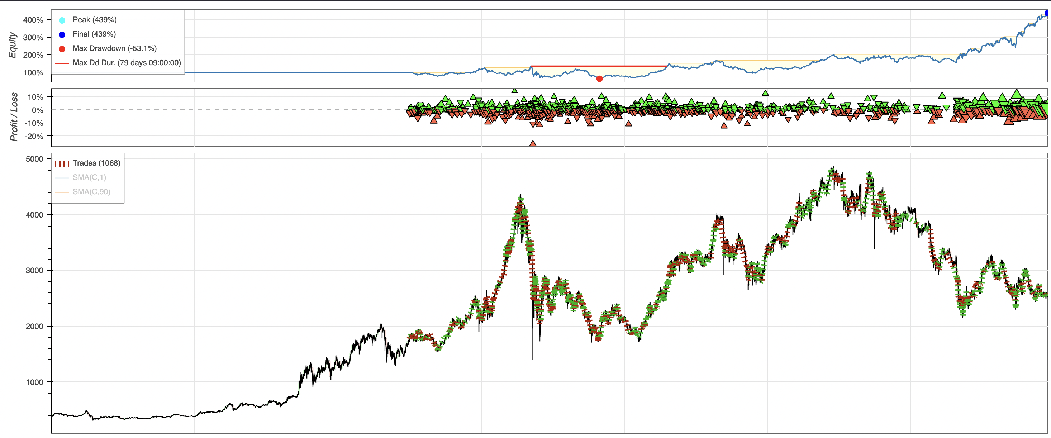

Figure 12: Equity curve of combined model (All ML models)

Figure 12 is the equity curve of All ML models combined model. When comparing it with market movement, we found that our model can generate a stable return no matter how volatile it is and even if there is a large downtrend in the market. The duration of maximum drawdown is just 79 days. This model performs incredibility well.

### 4.10 Performance of combined model (well-performed ML models)

We have also selected the well-performed models (RF, LSTM & CNN) that their Sharpe ratio is ≥ 1 for another combined model. The final trading signal is decided by the major voting of selected models. The result is as follows:

|  |  |  |  |  |  |  |  |  |  |  |
| --- | --- | --- | --- | --- | --- | --- | --- | --- | --- | --- |
| **Class** | | | | | | | | | | |
| “Buy” (1) | | | “Sell” (2) | | | “Hold” (0) | | | **Macro F1**  **score** | **Accuracy** |
| **Precision** | **Recall** | **F1** | **Precision** | **Recall** | **F1** | **Precision** | **Recall** | **F1** |
| 0.35 | 0.24 | 0.29 | 0.31 | 0.15 | 0.21 | 0.46 | 0.71 | 0.56 | 0.35 | 0.42 |

Table 27: Confusion matrix of combined model (Well-performed ML models)

|  |  |  |  |  |  |  |
| --- | --- | --- | --- | --- | --- | --- |
|  | Return | Sharpe Ratio | Sortino Ratio | Max. Drawdown | Win Rate | #Trade |
| Original | 33.24% | 0.78 | 0.3 | -72.44% | 53.65% | 1040 |

Table 28: P/L statistic of combined model (Well-performed ML models) with different trading fees

Table 29 is the confusion matrix of well performed ML models combined model. It archived 40% accuracy and 37% macro F1 score which is better than random trade 33% of accuracy. Prediction of Hold class has 52% F1 score which is better than 34% F1 score of Buy class and 25% F1 score of Sell class.

Table 30 is the P/L statistic of the well performed ML models combined model. It executed 1545 trades during the whole period. When there is no trading fee, this combined model loses 9.54%. The Sharpe ratio is 0.4 and the maximum drawdown is -66.9%.

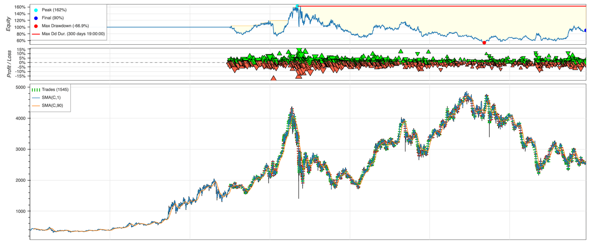

Figure 13: Equity curve of combined model (Well-performed ML models)

Figure 13 is the equity curve of the combined model of all well-performed induvial machine learning models. When comparing it with market movement, we found that in general, the equity curve is in a downtrend, especially in the period of the market uptrend, which is bad.

### 4.11 Summary table of all model performance

*Yellow highlighted items represented the best result in that situation.*

1. *Summary result of all models without transaction fee:*

|  |  |  |  |  |
| --- | --- | --- | --- | --- |
|  | **Total Return** | **Sharpe Ratio** | **Max Drawdown** | **#Trade** |
| **Buy & Hold** | 45.79% | 0.87 | -60.20% | 1 |
| **MLP** | 39.95% | 0.81 | -52.46% | 1534 |
| **KNN** | 4.79% | 0.55 | -59.67% | 1804 |
| **LSTM** | 156.84% | 1.42 | -73.80% | 1136 |
| **RF** | 154.59% | 1.42 | -61.4% | 1366 |
| **XGB** | 37.87% | 0.81 | -60.34% | 1738 |
| **CNN** | 482.89% | 2.25 | -47.74% | 1961 |
| **SMA** | 310.97% | 2.04 | -37.72% | 378 |
| **SMA plus BB** | 160.86% | 1.47 | -60.20% | 3 |
| **Combined Model (All ML model)** | 338.93% | 1.96 | -57.08% | 1068 |

1. *Summary result of all models with 0.05% transaction fee:*

|  |  |  |  |  |
| --- | --- | --- | --- | --- |
|  | **Total Return** | **Sharpe Ratio** | **Max Drawdown** | **#Trade** |
| **Buy & Hold** | 45.65% | 0.87 | -60.17% | 1 |
| **MLP** | -35.01% | -0.09 | -61.55% | 1534 |
| **KNN** | -57.47% | -0.35 | -74.19% | 1804 |
| **LSTM** | 45.69% | 0.86 | -78.15% | 1136 |
| **RF** | 28.67% | 0.75 | -66.98% | 1366 |
| **XGB** | -42.11% | -0.04 | -70.02% | 1738 |
| **CNN** | 118.7% | 1.27 | -54.63% | 1961 |
| **SMA** | 240.24% | 1.82 | -42.07% | 378 |
| **SMA plus BB** | 160.59% | 1.47 | -60.20% | 3 |
| **Combined Model (All ML model)** | 157.3% | 1.43 | -57.85% | 1068 |

1. *Summary result of all models with 0.2% transaction fee:*

|  |  |  |  |  |
| --- | --- | --- | --- | --- |
|  | **Total Return** | **Sharpe Ratio** | **Max Drawdown** | **#Trade** |
| **Buy & Hold** | 45.5% | 0.87 | -60.2% | 1 |
| **MLP** | -93.35% | -2.77 | -94.06% | 1534 |
| **KNN** | -97.01% | -3 | -97.14% | 1804 |
| **LSTM** | -73.54% | -0.81 | -89.22% | 1136 |
| **RF** | -83.37% | -1.27 | -92.4% | 1366 |
| **XGB** | -95.63% | -2.6 | -96.48% | 1738 |
| **CNN** | -88.29% | -1.63 | -90.16% | 1961 |
| **SMA** | 93.27% | 1.18 | -54.76% | 378 |
| **SMA plus BB** | 159.56% | 1.47 | -60.19% | 3 |
| **Combined Model (All ML model)** | -48.29% | -0.15 | -79.38% | 1068 |

# 5. Discussion

### 5.1 Usefulness of non-ETH pricing data

Our models have slightly better performance than random guess, most of the machine learning models achieve ~0.37 Macro F1 score. The paper we reviewed in Section 2.1.4 trained machine learning models to predict buy/sell signals and the unrestricted models get ~30% higher accuracy than restricted models. For hourly frequency, the best model has 0.84 accuracy. It reflects that their social media indicators can provide insights about market movement. Different from their data sources (GitHub and Reddit), we picked Twitter tweets to generate the social media indicators. But these indicators don’t seem to improve the performance of our models much, which reflects that the input data fed to the language models may have too much noise. As a substantial portion of the tweets are related to advertisements, the machine learning models cannot benefit from the generated social media indicators.

There are several ways to generate better social media indicators. First, manually filtering advertisements and unrelated tweets can improve the quality of the inputs to the language model, but as there are millions of tweets collected, it will take a lot of time to do so. Using other data sources such as news data, conversations in Telegram and Discord can also reduce the noise.

We also used fear and greed index, Bitcoin, and ETF pricing data. They did not make our models perform significantly better, despite feature scaling and dimensionality reduction were performed. To further improve the use of these data in the future, some indicators can be computed to capture the correlation between ETH futures and other assets.

### 5.2 Volatile return because of a volatile market?

In the normal nature of investment, the higher the expected return of the investment target, the higher the fluctuation risk that investors can tolerate. Conversely, the lower the expected remuneration. The lower the fluctuating risk. Therefore, the main purpose of rational investors choosing the investment target and portfolio is to pursue the maximum reward under the fixed risk, or to pursue the lowest risk under the fixed expected return.

Although the high-volatility market will bring high-risk returns to a considerable extent, it is not the main cause of volatile return. A good strategy can help investors to earn a steady income by hedging in volatile markets. CNN model in our project is a good example, given that the Ethereum futures market is high fluctuate from May 2021 to March 2022, however, CNN model still able to get 2.25 Sharpe ratio with 483% return. Besides, investors also can set stop loss or stop profit rules to further reduce the risk and earn profit.

### 5.3 Buy and hold strategy

Buffett said, “If you don’t plan to hold a stock for ten years, don’t hold it for ten minutes.” [31] This reflects Buffett’s value investing philosophy – buy and hold strategy. This strategy reduces transaction costs and management fees, is not affected by short-term market volatility, and is considered the best way to manage market risk. However, some investors interpret this strategy as “if you hold an asset long enough, you will get a high positive return.” It is not true. In our project, we entered the market in March 2021, which is a good entry time, so at the end Buy and Hold has 45.79% return with 0.87 Sharpe ratio due to high volatile of market. However, if we apply the same strategy at the beginning of a bear market, the losses will be greater, and possibly take a decade or more for the market to get back in place. Not to mention the opportunity cost during the long holding period.

Besides, some of our models mentioned in Section 4, such as LSTM, RF, CNN, SMA and SMA plus BB model are better than buy and hold in general, depending on different trading fee scenario, by comparing the return, Sharpe ratio and maximum drawdown. For example, when the trading fee is 0.05%, our CNN model has 118.7% return with 1.27 Sharp ratio and -54.63% maximum drawdown; but buy and hold strategy only got 45.65% return with 0.87 Sharpe ratio and -60% maximum drawdown. That is because these models have higher trading frequency and have market risk tolerance capability.

### 5.4 Is combined model necessarily better? What else to do to make it better?

In our experiments, we have 2 combined models, first is combining all machine learning models (Section 4.9) and another one is combining All well-performed machine learning (Section 4.10) whose Sharpe ratio is greater or equal to 1. The first combined model performed well, it got 43% accuracy, 35% macro F1 score, 1.96 Sharpe ratio, and 338.93% return from our backtesting. Its performance is better than the Buy and Hold strategy and close to the SMA crossover strategy. For the second combined model, unfortunately, its performance is bad, although it got 42% accuracy and 35% macro F1 score which is similar to the first combined model, its Sharpe ratio is 0.78 and the return is 33.24% which is worse and unsatisfactory. Both are just simple combined models, and they are all using majority voting with equal weighting, not to mention there are many possible ways to combine models, different combining approaches may lead to different results. Based on our existing result, it reflects that combining models can have possibility to archive good performance, however, it is difficult to conclude it can be better than others. There are many things we can make to further improve our combined models, such as using Generic Algorithm to search the best combination of weighting for each model.

### 5.5 Trading fee consideration

In our experiments, whenever the model makes any trading decision, it used the whole balance to buy/sell. If there is an existing long position and the model outputs a buy signal, it will not place any trades until the model outputs a sell signal to close all existing positions for releasing money for the next trade. We have backtested using different trading feesscenario, no cost, 0.05% fee per trade, and 0.2% fee per trade. We can observe the result in Section 4, there is no change in the number of trades for the cost adjustment. If the trading frequency is low, such as SMA and SMA with Bolling band models, no matter how much the trading cost is, the return and Sharpe ratio are similar. However, if the trading frequency is high, it tends to gain more profit when the cost of trade is lower.

### 5.6 ML vs Traditional: return, risk, trade frequency

Machine Learning models such as CNN, archived 2.25 Sharpe ratio and traditional trading strategies like SMA crossover can archived 2.04 Sharpe ratio. Both are possible to have high returns with minimal risk. We observed the main difference is Machine Learning models usually having higher trade frequency than traditional strategies, CNN model has 1961 trades while the SMA crossover strategy has only 378 trades. Because Machine Learning models have a higher frequency, when there is a cost per trade, it tends to pay more trading fee, such as 0.05% cost per trade, the return of CNN model drop significantly from 483% to 119%, which is a significant reduction. Besides, machine learning models are difficult to interpret, and it is hard to understand why the model has made such a decision. On the other hand, the traditional strategy is a simple rules-based model, we can easily understand and fine-tune it.

### 5.7 Inefficient market

Effective market hypothesis means the information in the market has been timely, accurately, and fully reflected in the price trend, including the current and future value of the asset, unless there is market manipulation, otherwise, investors can't obtain excess profits above the market average by analyzing past prices [32]. The random walk strategy is 33% accurate, however, based on our result, random walk is worse than most of our models. Also, the win rate of our models in general is low but sometimes it can capture the big bull or bear trend**.** Hence**,** the market is likely inefficient.

### 5.8 What is the “tread”? How to capture it successfully?

When we buy and sell stocks, we often try to find the trend and make money from the trend. But actually, what is the trend? How to confirm whether the trend is true or fake? Taking our study as an example, we found a rapid rise from 24 April 2021 to 11 May 2021 and then rapid fall in stock prices from 12 May 2021 to 24 May 2021. Should we identify the rapid rise as a trend too? The answer is “it depends”. If we were employing a high trading frequency approach, we should identify this rapid rise as an opportunity and tried to capture the rapid price movement. With reference to our equity curve of SMA (Figure 10), when we used the SMA model, we did succeed in making profit in that rapid trend. But the disadvantage was that it would increase our trading frequency and eat into our profits when the market is highly fluctuating. Therefore, we further developed an advanced model called Moving Average plus Bollinger Bands, which can help to reduce the trading frequency by ignoring those rapid rises or fall movements. It means that the model would treat those rapid movements as fake trends.

With reference to our equity curve of SMA plus BB (Figure 11), our model would ignore the rapid rise and fall from 24 April 2021 to 24 May 2021, but successfully capture the long movement of fall from Nov 2021 to Mar 2022.

### 5.9 History doesn't really repeat itself?

Many investors in the market aim to find the trend or economic cycle from history and then tried to predict the future price movement. Some people who believe in technical analysis try to find relevant trends or cycles by using statistical methods.

We believe whether history will repeat itself is still a major issue in the academic world. From our study, although we found that technical analysis does and does generate profits for us, it does not mean that it will continue to be effective in the future. Because only about two years of data were used for the analysis, and cryptocurrencies have been existed more than 10 years.

Indeed, there are actually different reasons behind each large price movement, such as economic factors, political factors, inflation rate, etc. Therefore, our above analysis may only be a coincidence and does not have the ability to predict the trend of prices actually.

# 6. Challenges

### 6.1 Too much noise in Twitter data

Data quality is critical for a machine learning model as every noise in the dataset may affect the performance of the model. In our project, we have done some basic data cleaning and preprocessing on the social media data, for example, correcting misspelled wording, converting emoji symbols to words, removing URLs, etc. However, we found there is possible that some tweets are advertisement-like messages such as selling crypto coin exchange platforms. These tweets are difficult to identify and will generate noise.

### 6.2 Determine the architecture of neural networks like CNN

Some neural networks such as CNN are required to design your model architecture. Since there are a lot of possible combinations of layers, the sequence of each layer, and hyperparameters, it takes time to experiment and evaluate each setting, hence, it is not easy to find out the most optimal model for our problem.

### 6.3 Not enough data because Ethereum futures contract is new

Ethereum perpetual futures on Binance was introduced in November 2019 [33]. We have collected the historical hourly candlestick data from August 2020 to March 2022 which contains 14,159 records in total. It is not sufficient for machine learning models to study the historical price patterns. Especially in the first 25% records, from the product’s launch date to December 2020, the price is in a stable state, but since then, the price is highly volatile.

### 6.4 Difficult to evaluate the fair value of cryptocurrency

Cryptocurrency is a new and hot topic in recent years. Unlike traditional financial assets, it has no substantial value or legal recognition, which makes many traditional financial models or fundamental analysis (e.g., discounted cash flow method) unusable to be applied. It is difficult for us to find the fair value of cryptocurrency and evaluate whether it is over/under-valued.

# 7. Future work

We have concluded the following potential future works:

### 7.1 More complex models

The higher the model complexity usually has smaller training error as it can better extract and learn the pattern from the training dataset, especially for our high complex non-linear problem. Hence, we can further attempt more complex models such as using transformer models to predict sentiment features.

### 7.2 Better and more variety of social media data

As we mentioned in Section 5.1, our Twitter tweets social media data do not improve the performance of our models as the paper we studied. It is possible that our dataset contains noise such as advertisements. Since it is challenging to perform data cleaning on social media data, we can explore more high quality and reliable data sources that can help to generate sentiment features, such as news data.

### 7.3 Grid search for hyperparameters tuning

Fine-tuning the hyperparameters of each model is challenging and requires experiments. Using the grid search approach can help us to automate and simplify the testing of different combinations of setting and then find the more optimal parameters. Depending on the complexity of fine-tuning, the entire process may take a longer time.

### 7.4 TP/SL/Dynamic Position Size trading strategies

In our backtesting, we long/short the position based on the trading signal. However, we have not considered using stop loss, stop profit, or even dynamic position size trading strategies to prevent the risk from the high volatile market. Since these strategies could also be backtested with our models as a whole, and in reality, investors set stop-loss to lock their maximum potential losses, the profitability can be better especially when we evaluate with P/L statistics.

### 7.5 More alphas & new technical indicators

The best ways to improve the performance of machine learning models is to get more features and training data such as adding more high-quality technical indicators and alphas to each record to avoid overfitting.

### 7.6 More comprehensive traditional rule-based models

In our project, we have back tested most common and well-known strategies i.e., SMA crossover and SMA plus Bolling band. Although both have satisfactory performance in our backtests, there are still many traditional financial models have not yet been tested.

### 7.7 Genetic Algorithms to pick models or assign weights

Two combined models (Section 4.9 & 4.10) use majority voting with equal weighting approach to decide the final trading signal. We can further fine-tune the combined model by using Genetic Algorithm to search the best combination of weighing to each sub-models and select the best combination of models.

### 7.8 Combine machine learning models with traditional technical strategies

Due to time limitation, we only attempted to combine machine learning models but have not tried to combine machine learning models with technical rule-based strategies complement each other as we could see some of our machine learning models aggressively target to gain profit without the capability to detect sudden downtrends, while technical rule-based strategies are more conservative and stable.

### 7.9 Further extending the sample type, size, and testing period

In our project, we only consider one type of cryptocurrencies (i.e., Ethereum (ETH)) and its relevant derivative: Ethereum USDM perpetual futures contract with the data from 2 August 2020, 2 am to 15 March 2022, 0 am. Indeed, there are different types of cryptocurrencies and derivatives existed in the market. We should further perform analysis on other major type of cryptocurrencies such as Bitcoin and tried to find the correlation between them.

### 7.10 Portfolio optimization

In our current study, we only focused on ETH futures and a few machine learning models and traditional financial models. As aforementioned, there are a vast number of cryptocurrencies and trading models available in the market. From an investment perspective, we should think of it as an investment portfolio management, which means we should not just focus on cryptocurrencies, but also include other type of financial products e.g., stocks, bonds, and currencies into our portfolio for risk diversification purpose.

# 8. Conclusions

We have presented some machine learning and traditional financial techniques with the aim of stabilizing the return and minimizing the drawdown. It is hard to fully understand the inner workings of cryptocurrency markets. There are a number of factors contributing to the anticipated and unanticipated market fluctuations, such as market manipulation and speculative trading. In Section 4, we presented the performance of our strategies. There is some degree of predictability of short-term price movements of Ethereum futures, though it is hard to have accurate predictions. Some individual models like the CNN model and the combined model consists of all our ML models can generate good profits under 0 and 0.05% trading fee rate. Although the win rates of the machine learning models are all above 50% under 0 and 0.05% trading fee rate, not all of them are able to generate good returns. It is noteworthy that favorable results may exist by chance. More pricing data is needed to further validate the performance of the ML models. Also, short-term trading with high trading fee rate reduces the profitability of our strategies. With remarkably high trading fee rate (i.e., 0.2%), the machine learning models are unable to generate profits. Our machine learning models may get better performance if daily pricing data and risk management techniques like position sizing and stop loss are used.

Moreover, the generated social media indicators may not be dependable due to too much noise in the collected tweets. However, there are some ways to improve the quality of sentiment data.

Different from machine learning models, the traditional financial models have stabler performance. We proved that our SMA strategy and SMA plus BB strategy can work well on trading new virtual assets such as cryptocurrency. The motivation of these strategies is not to predict next hour’s price movement, but to capture the flags of bull/bear market run. It reflects that the usefulness of technical analysis and chart patterns do exist. History repeats but does not necessarily replicating the prior patterns.

There are still lots of potential areas to improve our trading strategies. An important avenue for future work is to enhance the quality and variety of input data. With better trading techniques and advanced algorithms like majority voting genetic programming classifier [34], better trading performance may achieve. The wisdom of the crowds often gives better predictions, as in random forest. Some recommendations for future works are given. We hope that our results can provide directions for future research to explore.

# Bibliography

|  |  |
| --- | --- |
| [1] | M. Ortu, N. Uras, C. Conversano, S. Bartolucci and G. Destefanis, "On technical trading and social media indicators for cryptocurrency price classification through deep learning," *Expert Systems with Applications,* vol. 198, 2022. |
| [2] | M. K. Hassan, F. A. Hudaefi and R. E. Caraka, "Mining netizen's opinion on cryptocurrency: sentiment analysis of Twitter data," *Studies in Economics and Finance,* no. 39, pp. 365-385, 2021. |
| [3] | Muhammad Abubakr Naeem, Imen Mbarki,Muhammed Tahir Suleman,Xuan Vinh Vo,Syed Jawad Hussain Shahzad, "Does Twitter Happiness Sentiment predict cryptocurrency?," *International Review of Finance,* 16 December 2020. |
| [4] | Olivier Kraaijeveld, Johannes De Smedt, "The predictive power of public Twitter sentiment for forecasting cryptocurrency prices," *Journal of International Financial Markets, Institutions and Money,* March 2020. |
| [5] | F. Valencia, A. Gómez-Espinosa and B. Valdés-Aguirre, "Price Movement Prediction of Cryptocurrencies Using Sentiment Analysis and Machine Learning," *Entropy (Basel),* 2019. |
| [6] | H. K. Sul, A. R. Dennis and L. I. Yuan, "Trading on Twitter: Using Social Media Sentiment to Predict Stock Returns: Trading on Twitter," *Decision Sciences,* p. 48, 2016. |
| [7] | G. Y. Yongfeng Wang, " Survey on the application of deep learning in algorithmic trading," *Data Science in Finance and Economics ,* vol. 1, no. 4, pp. 345-361, 2021. |
| [8] | Mohammed Mudassir, Shada Bennbaia, Devrim Unal, Mohammad Hammoudeh , "Time-series forecasting of Bitcoin prices using high-dimensional features: a machine learning approach," *Neural Computing and Applications,* pp. 1-15, 4 July 2020. |
| [9] | K. Grobys, N. Sapkota and S. Ahmed, "Technical trading rules in the cryptocurrency market," *Finance Research Letters,* vol. 32, 2020. |
| [10] | Y. Ni, P. Huang, Y. Cheng and M.-Y. Day, "The profitability of Bollinger Bands trading bitcoin futures," 31 Mar 2022.. |
| [11] | Binance, "What Is Futures Funding Rate And Why It Matters," [Online]. Available: https://www.binance.com/en/blog/futures/what-is-futures-funding-rate-and-why-it-matters-421499824684903247. [Accessed 31 July 2022]. |
| [12] | Bybit, "Contract Rules｜Bybit Crypto Margin Trading," [Online]. Available: https://www.bybit.com/data/contract-rules. [Accessed 31 July 2022]. |
| [13] | Backtest.py, "Backtesting.py - Backtest trading strategies in Python," [Online]. Available: https://kernc.github.io/backtesting.py/. [Accessed 31 July 2022]. |
| [14] | Binance, "Trading Fees," 31 July 2022. [Online]. Available: https://www.binance.com/en/fee/futureFee. |
| [15] | MacroMicro, "Crypto Fear & Greed Index," [Online]. Available: https://en.macromicro.me/charts/34417/crypto-fear-greed-index. [Accessed 31 July 2022]. |
| [16] | V. E. I. Group, "Vanguard S&P 500 ETF (VOO)," [Online]. Available: https://investor.vanguard.com/investment-products/etfs/profile/voo. [Accessed 31 July 2022]. |
| [17] | I. C. Management, "About QQQ - Holdings and Sector Allocations - Invesco," [Online]. Available: https://www.invesco.com/qqq-etf/en/about.html. [Accessed 31 July 2022]. |
| [18] | SNScrape, "SNScrape - A social networking service scraper in Python," [Online]. Available: https://github.com/JustAnotherArchivist/snscrape. [Accessed 31 July 2022]. |
| [19] | Z. Kakushadze, "101 Formulaic Alphas," *Wilmott Magazine,* pp. 72-80, 10 December 2015. |
| [20] | A. Akalin, "Computational Genomics with R," [Online]. Available: https://compgenomr.github.io/book/dealing-with-correlated-predictors.html. [Accessed 31 July 2022]. |
| [21] | Asifullah Khan, Anabia Sohail, Umme Zahoora, Aqsa Saeed Qureshi, "A Survey of the Recent Architectures of Deep Convolutional Neural Networks," *Artificial Intelligence Review,* p. 5455–5516, 2020. |
| [22] | G. W. Lindsay, "Convolutional Neural Networks as a Model of the Visual System: Past, Present, and Future," *Journal of Cognitive Neuroscience,* pp. 2017-2031, 1 September 2021. |
| [23] | IBM, "What are Convolutional Neural Networks? - IBM," [Online]. Available: https://www.ibm.com/cloud/learn/convolutional-neural-networks. [Accessed 31 July 2022]. |
| [24] | "The Vanishing Gradient Problem During Learning Recurrent Neural Nets and Problem Solutions," *International Journal of Uncertainty Fuzziness and Knowledge-Based Systems,* pp. 107-116, April 1998. |
| [25] | Savvas Varsamopoulos , Koen Bertels , Carmen G. Almudever, "Designing neural network based decoders for surface codes," [Online]. Available: https://www.researchgate.net/figure/Structure-of-the-LSTM-cell-and-equations-that-describe-the-gates-of-an-LSTM-cell_fig5_329362532. [Accessed 31 July 2022]. |
| [26] | Bradley Boehmke, Brandon Greenwell, "Hands-On Machine Learning with R," 1 February 2020. [Online]. Available: https://bradleyboehmke.github.io/HOML/random-forest.html. [Accessed 31 July 2022]. |
| [27] | Tianqi Chen, Tong He, "xgboost: eXtreme Gradient Boosting," 16 April 2022. [Online]. Available: https://cran.r-project.org/web/packages/xgboost/vignettes/xgboost.pdf. [Accessed 31 July 2022]. |
| [28] | C. N. group, "Twitter-roBERTa-base," [Online]. Available: https://huggingface.co/cardiffnlp/twitter-roberta-base. [Accessed 31 July 2022]. |
| [29] | O. Adnane, "Tweet Emotions Analysis using-LSTM-Glove-RoBERTA," Kaggle, 13 July 2020. [Online]. Available: https://www.kaggle.com/code/ishivinal/tweet-emotions-analysis-using-lstm-glove-roberta?scriptVersionId=38608295. [Accessed 31 July 2022]. |
| [30] | M. Kulakowski, "CryptoBERT," [Online]. Available: https://huggingface.co/ElKulako/cryptobert. [Accessed 31 July 2022]. |
| [31] | M. Fool, "If Warren Buffett Isn't Afraid to Cut His Losses, Then You Shouldn't Be Either," The Globe And Mail, 26 July 2022. [Online]. Available: https://www.theglobeandmail.com/investing/markets/stocks/ORCL-N/pressreleases/9317721/if-warren-buffett-isnt-afraid-to-cut-his-losses-then-you-shouldnt-be-either/. |
| [32] | E. F. Fama, "Efficient Capital Markets: A Review of Theory and Empirical Work," *The Journal of Finance ,* vol. 25, no. 2, pp. 383-417, 1970. |
| [33] | Binance, "Binance Futures Trading Platform Launches ETH/USDT Contracts with 50x Max Leverage," 29 November 2019. [Online]. Available: https://www.binance.com/en/blog/all/binance-futures-trading-platform-launches-ethusdt-contracts-with-50x-max-leverage-407077773202501632. [Accessed 31 July 2022]. |
| [34] | Topon Kumar Paul and Hitoshi Iba, "Prediction of Cancer Class with Majority Voting Genetic Programming Classifier Using Gene Expression Data," *IEEE/ACM Transactions on Computational Biology and Bioinformatics,* pp. 353-367, April-June 2009. |
| [35] | D. Loureiro, F. Barbieri, L. Neves, L. E. Anke and J. Camacho-Collados, "TimeLMs: Diachronic Language Models from Twitter," *Proceedings of the 60th Annual Meeting of the Association for Computational Linguistics: System Demonstrations,* 2022. |

# Appendices

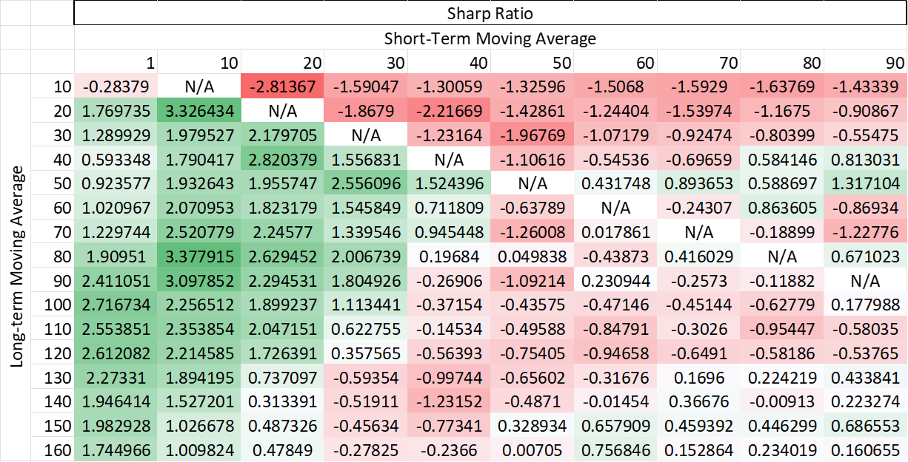

Figure A.1: SMA - Trial and Error result on training dataset - Sharpe Ratio

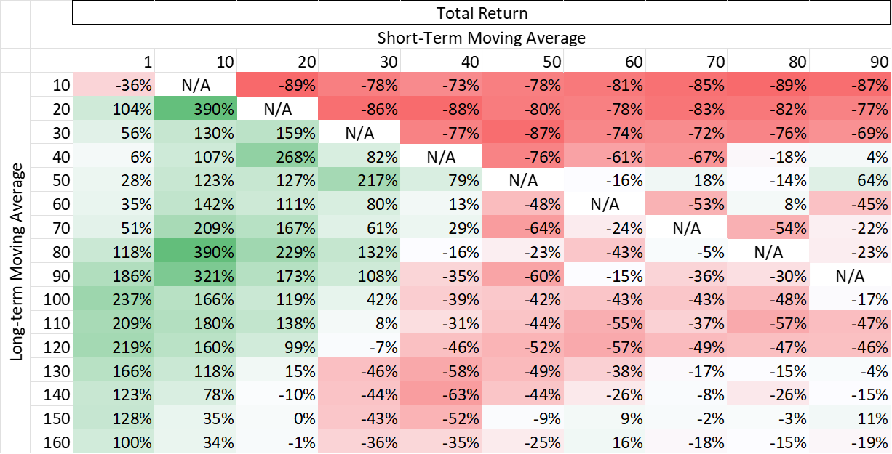

Figure A.2: SMA - Trial and Error result on training dataset - Total Return

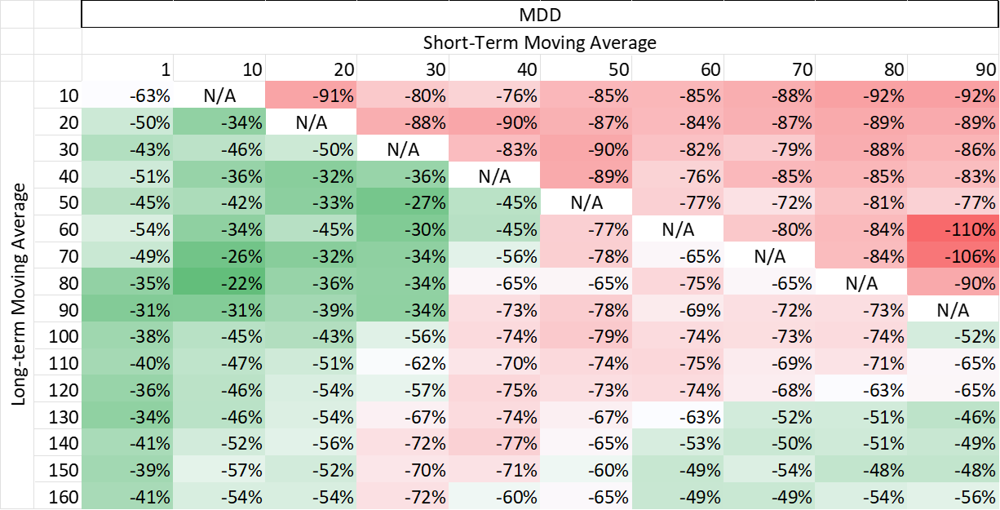

Figure A.3: SMA - Trial and Error result on training dataset - Maximum Drawdown

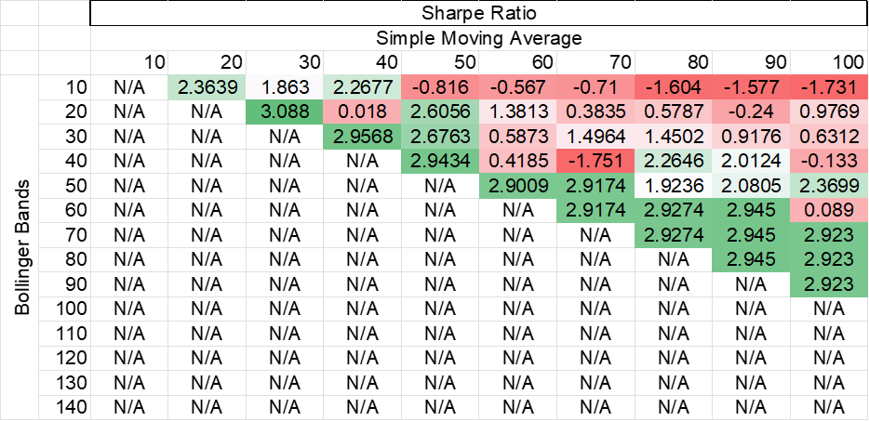

Figure A.4: SMA plus BB - Trial and Error result on training dataset - Sharpe Ratio

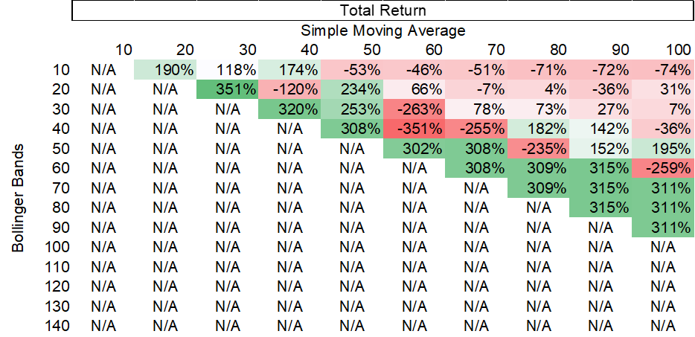

Figure A.5: SMA plus BB - Trial and Error result on training dataset - Total Return

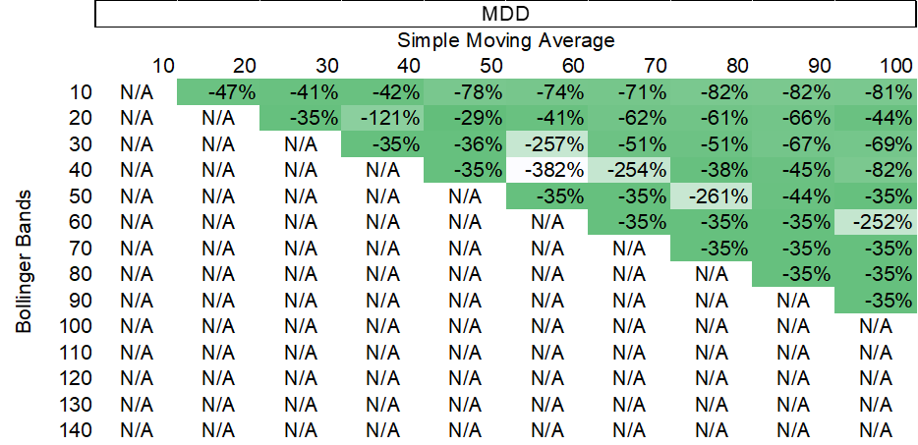

Figure A.6: SMA plus BB - Trial and Error result on training dataset - Maximum Drawdown

# 

# Declaration of the contribution of each individual member of the group

|  |  |
| --- | --- |
| Group Member | Duties |
| Wong Ka Kit | * Research on different traditional financial modelling * Professional financial knowledge contributions * Models and strategies design and implementation   + Traditional financial models     - Buy and Hold     - SMA     - SMA plus BB * Backtesting   + Traditional financial models     - Buy and Hold     - SMA     - SMA plus BB * Selecting performance evaluation methods   + - Sharpe Ratio     - Maximum Drawdown     - Total return * Generating and verifying the formula and results by Excel and manual calculation * Documentations   + Project proposal   + Project detailed proposal (traditional financial models part)   + Interim Report (traditional financial models part)   + Interim Presentation Slides     - SMA     - SMA plus BB   + Final Report     - Introduction     - Literature Review (2.2.1, 2.2.2)     - Methodology (3.7.7 & 3.7.8, 3.9)     - Results (4.7, 4.8, 4.11)     - Discussion (5.3, 5.5 & 5.7 outline, and 5.8, 5.9)     - Challenges (6.4)     - Future work (7.6 outline and 7.9, 7.10)     - Conclusion (with Wong Ngai Sum)     - Fixing formatting, grammar & spelling mistakes     - Bibliography   + Final Presentation Slides     - Traditional Trading Model - SMA     - Traditional Trading Model   – SMA plus BB   * + - Further issues to explore on  Traditional Financial Models     - Challenges on Traditional Financial Models     - Potential Future works on Traditional Financial Models     - Overall Result on all models * Project management (traditional financial models)   Overall time contribution: ~200 hours |
| Wong Ngai Sum | * Programming   + ML models     - MLP     - LSTM     - Random forest     - XGBoost     - KNN   + Traditional strategies using backtesting.py library     - SMA (with Janus)     - SMA + BB (with Janus)   + Debugging and testing   + Buy and hold strategy   + Generation and selection of technical indicators and alphas   + Calculation of Sharpe ratios   + Base code for backtesting * Data collection   + ETH futures data   + Fear and greed index   + Research on web scraping tools to collect tweets   + Twitter tweets scraping (with Janus) * Results generation   + Some backtesting results of ML models and traditional strategies   + Generation of social media indicators * Documentations   + Project proposal   + Project detailed proposal   + Interim report   + Presentation slides   + Final report (similar as in interim report)     - Introduction (Section 1)     - Literature review (2.1.1 - 2.1.5)     - Methodology (Section 3)     - Discussion (5.1, outline of 5.2 – 5.7)     - Challenges (outline of 6.1 & 6.2)     - Further work (outline of 7.1 – 7.8)     - Conclusions (other content not related to traditional trading strategies)     - Acknowledgements     - Add citations, fix grammar mistakes     - Mathematical formulas for traditional trading strategies * Research design   + 2nd and 3rd language model   + Planning of experiments and methods for results analysis   + Selection of machine learning models * Project management   + Group project leader   + Assisting Wong Ka Kit in verifying his results and results generated by backtesting.py |
| Lin Ho Ching Janus | * Documentations   + Project proposal (have discussed with Wong Ngai Sum and Wong Ka Kit, but I wrote the whole document)   + Project detailed proposal     - Aim     - Proposed Methodology (1, 2, 3, 4.1, 4.2, 4.4)     - Milestones     - Deliverables     - Add citations, fix grammar mistakes   + Interim Report     - Introduction     - Project Aims and Objective     - Methodology (4.1, 4.2, 4.3, 4.4, 4.5, 4.6, 4.7, 4.6.1, 4.6.2, 4.6.3, 4.6.4)     - Project Progress     - Preliminary Results and Evaluation (6.1)     - Challenges Faced during the Result (7.1)     - Future Work (8.1, 8.2, 8.3, 8.4, 8.5)     - Schedule     - Add citations, fix grammar mistakes   + Final Report     - Abstract     - Results (4.1, 4.2, 4.3, 4.4, 4.5, 4.6, 4.9, 4.10)     - Discussion (5.2, 5.3, 5.4, 5.5, 5.6, 5.7)     - Challenges (6.1, 6.2, 6.3)     - Future work (7.1, 7.2, 7.3, 7.4, 7.5, 7.6, 7.7, 7.8)     - Add citations, fix grammar mistakes * Interim Presentation Slides   + Introduction   + Methodology   + Preliminary Result     - CNN     - MLP (with Wong Ngai Sum)     - LSTM (with Wong Ngai Sum)     - KNN (with Wong Ngai Sum)   + Challenge   + Next Work * Final Presentation Slides (**our team not yet started to work on the slides at the time we wrote the report, but I must contribute on it, so I have added this item) * Data collection   + Bitcoin   + VOO (it needs some programming works to call broker’s API)   + QQQ (it needs some programming works to call broker’s API)   + Twitter (with Wong Ngai Sum) * Programming – Implementation (Python)   + CNN   + Combined model 2   + SMA (With Wong Ngai Sum)   + SMA with Bolling band (With Wong Ngai Sum)   + Sentiment Data (With Wong Ngai Sum)   + Base code for backtesting (with Wong Ngai Sum) * Model Design, Testing and Tuning (Python)   + CNN   + Combined model 1   + Combined model 2   + SMA   + Sentiment Data (With Wong Ngai Sum)   + SMA with Bolling band * Result Generation   + All machine learning models, SMA, SMA + BB, All Combined models (With Wong Ngai Sum)   (non-actual work such as research, group discussion, etc. have not included in this list) |